Chapter 1
Introduction
A note on the use of these PowerPoint slides:
We’re making these slides freely available to all (faculty, students, readers). They’re in PowerPoint form so you see the animations; and can add, modify, and delete slides (including this one) and slide content to suit your needs. They obviously represent a lot of work on our part. In return for use, we only ask the following:
- If you use these slides (e.g., in a class) that you mention their source (after all, we’d like people to use our book!)
- If you post any slides on a www site, that you note that they are adapted from (or perhaps identical to) our slides, and note our copyright of this material.
For a revision history, see the slide note for this page.
Thanks and enjoy! JFK/KWR
All material copyright 1996-2023
J.F Kurose and K.W. Ross, All Rights Reserved

Computer Networking: A Top-Down Approach
8th edition
Jim Kurose, Keith Ross Pearson, 2020

Chapter 1: introduction
Chapter goal:
- Get “feel,” “big picture,” introduction to terminology
• more depth, detail later in course

Overview/roadmap:
- What is the Internet? What is a protocol?
- Network edge: hosts, access network, physical media
- Network core: packet/circuit switching, internet structure
- Performance: loss, delay, throughput
- Protocol layers, service models
- Security
- History

The Internet: a “nuts and bolts” view
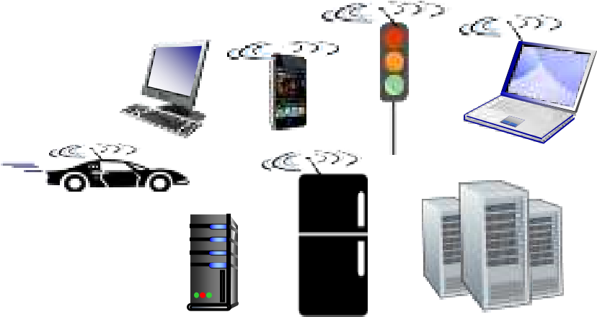
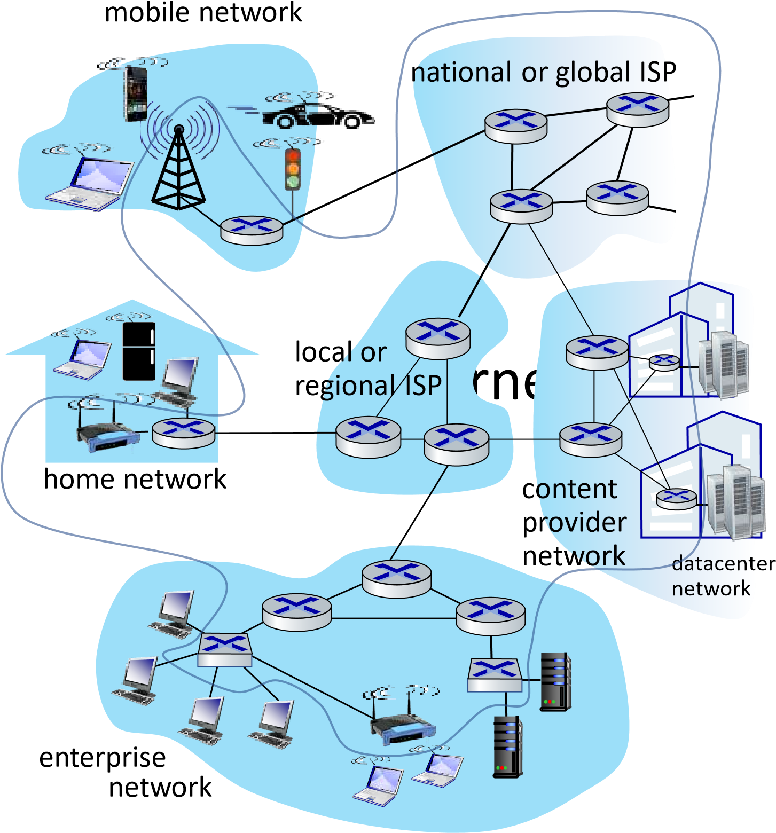


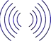
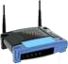
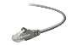
Billions of connected computing devices:
- hosts = end systems
- running network apps at Internet’s “edge”
Packet switches: forward packets (chunks of data)
- routers, switches
Communication links
- fiber, copper, radio, satellite
- transmission rate: bandwidth
Networks
- collection of devices, routers, links: managed by an organization

“Fun” Internet-connected devices


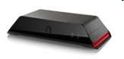


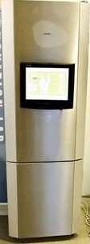

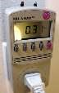




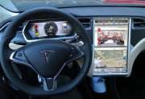


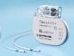




Amazon Echo
Web
-
enabled toaster +
weather forecaster
Slingbox: remote
control cable TV
Security Camera
IP picture frame
Internet
refrigerator
Tweet
-
a
-
watt:
monitor energy use
sensorized,
bed
mattress
Others?
Gaming devices
cars
scooters
bikes
Pacemaker & Monitor
AR devices
Fitbit
diapers
Internet phones

The Internet: a “nuts and bolts” view
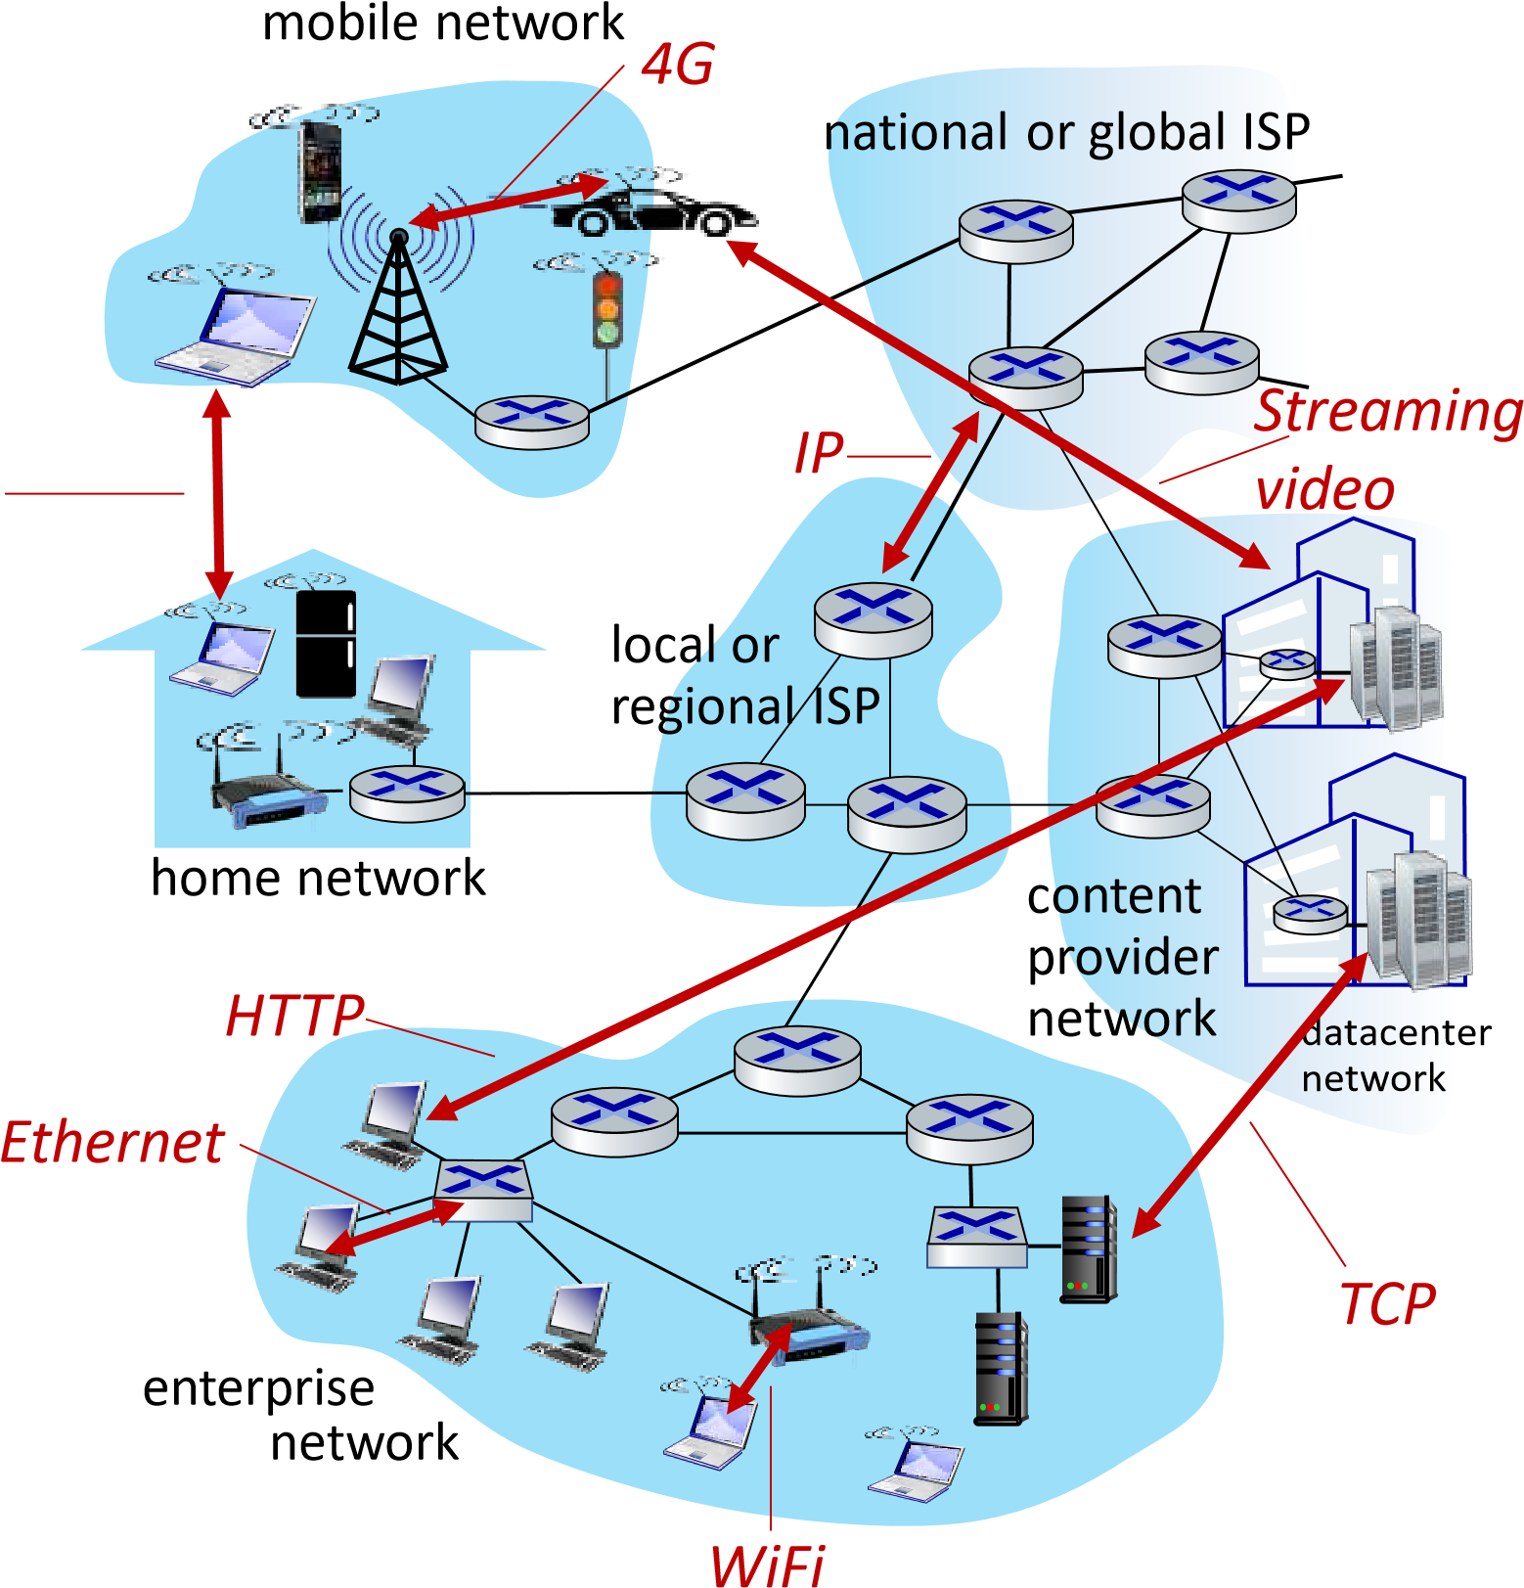
- Internet: “network of networks”
  - Interconnected ISPs
- protocols are everywhere
Skype
  - control sending, receiving of messages
  - e.g., HTTP (Web), streaming video, Skype, TCP, IP, WiFi, 4/5G, Ethernet
- Internet standards
    - RFC: Request for Comments
    - IETF: Internet Engineering Task Force

The Internet: a “services” view
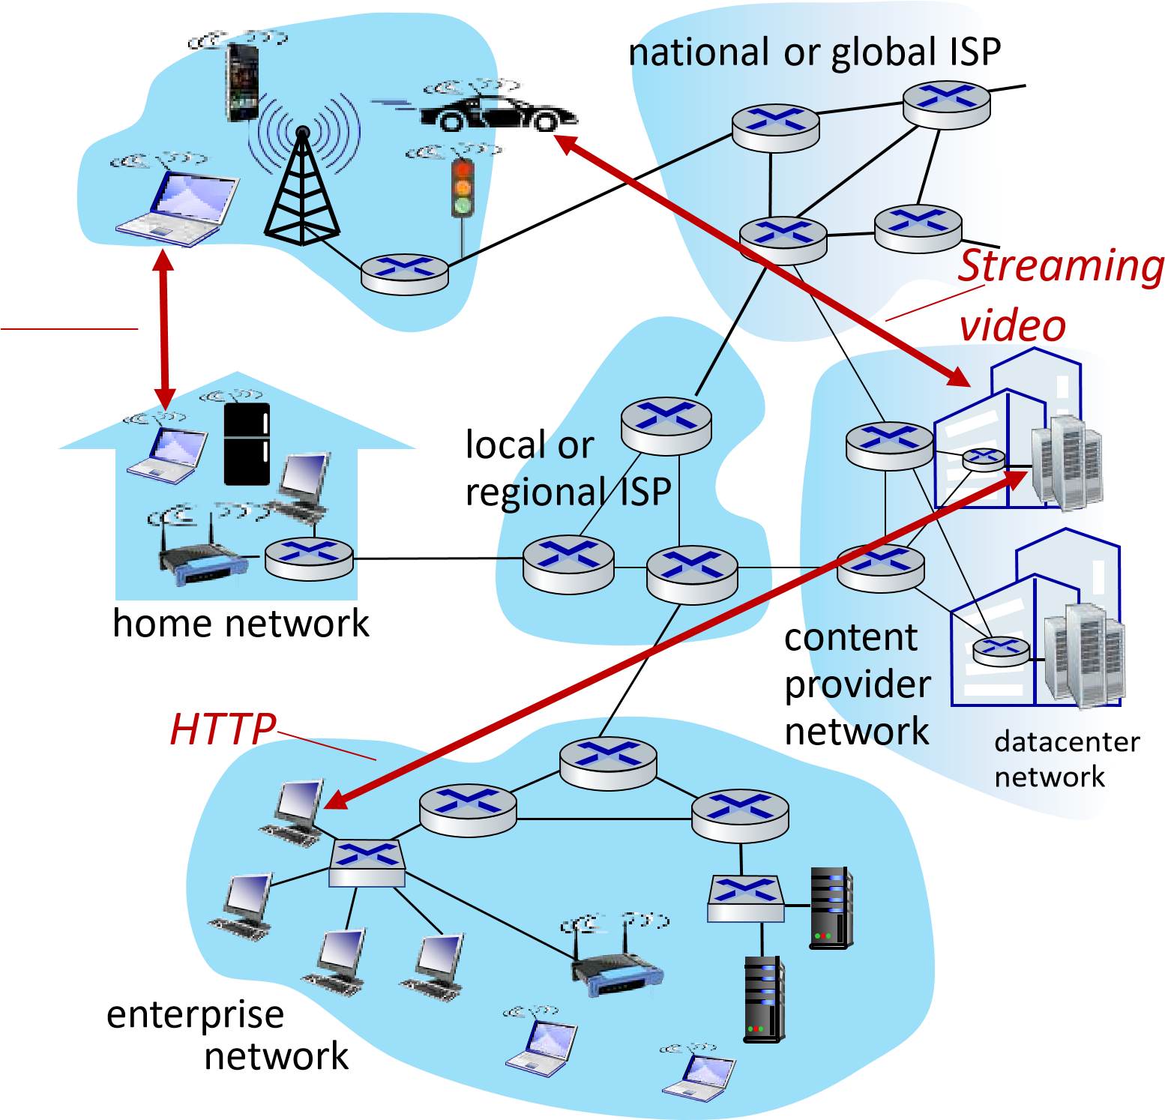
- Infrastructure that provides ^{mobile network} services to applications:
  - Web, streaming video, multimedia teleconferencing, email, games, ecommerce, social media, inter- Skype connected appliances, …
- provides programming interface to distributed applications:
  - “hooks” allowing sending/receiving apps to “connect” to, use Internet transport service
  - provides service options, analogous to postal service

What’s a protocol?
Human protocols:
- “what’s the time?”
- “I have a question”
- introductions
Network protocols:
- computers (devices) rather than humans
- all communication activity in Internet governed by protocols

Rules for:
… specific messages sent
… specific actions taken when message received, or other events
Protocols define the format, order of messages sent and received among network entities, and actions taken on message transmission, receipt

What’s a protocol?
A human protocol and a computer network protocol:
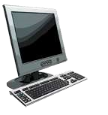
Hi
Hi
Got the
time?
2:00
time
TCP connection
response
>
file
<
TCP connecti
on
request
GET
se_ross
tp://gaia.cs.umass.edu/kuro
ht
Q: other human protocols?

Chapter 1: roadmap
- What is the Internet?
- What is a protocol?
- Network edge: hosts, access network, physical media
- Network core: packet/circuit switching, internet structure
- Performance: loss, delay, throughput
- Security
- Protocol layers, service models
- History

Network edge:
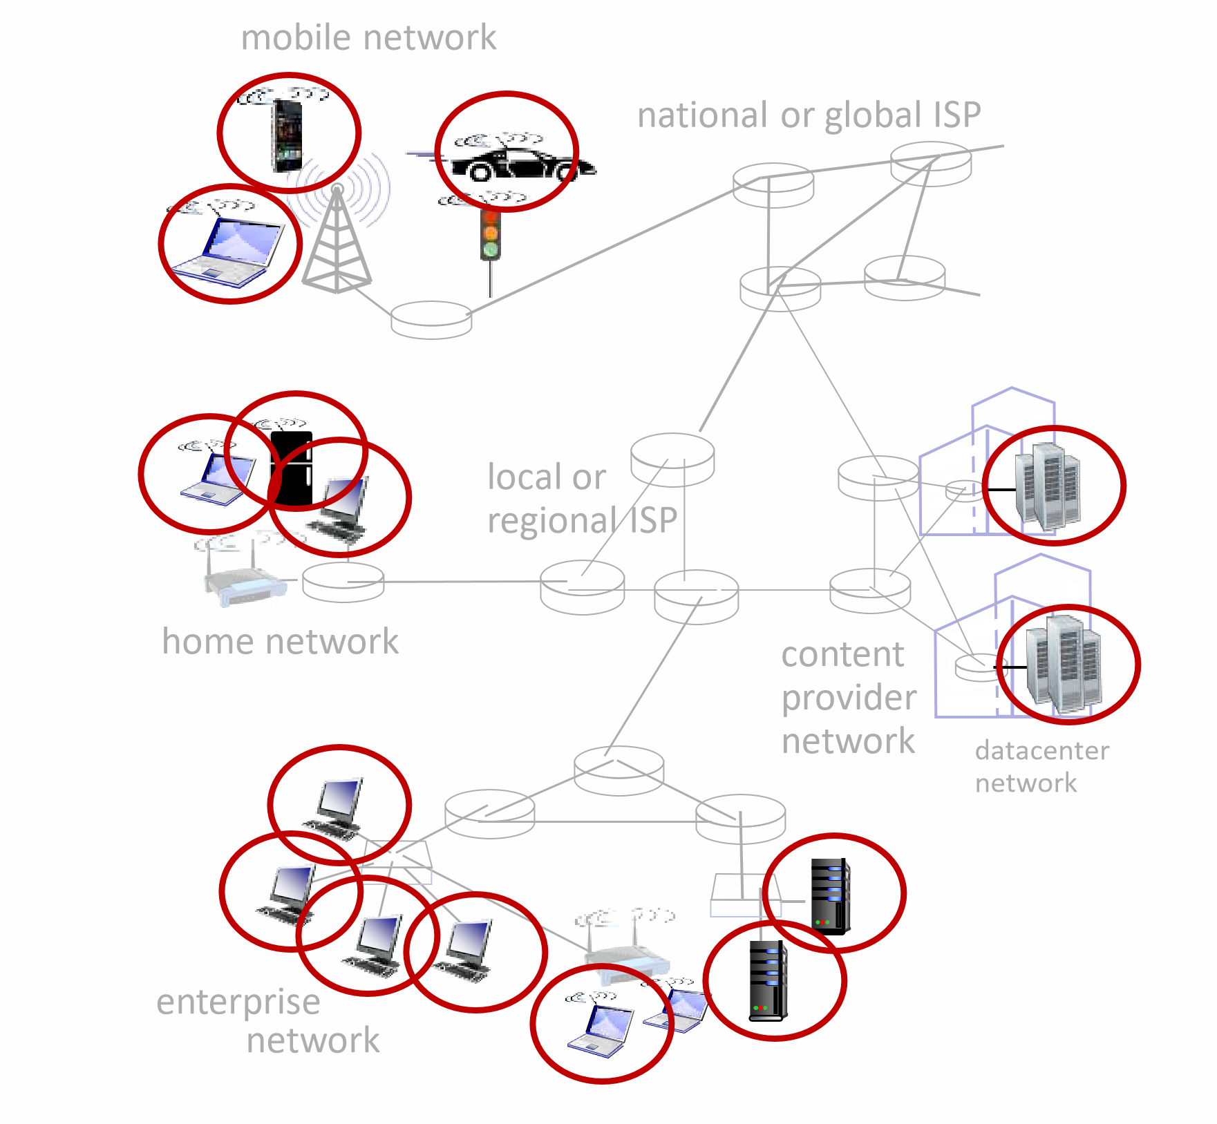
- hosts: clients and servers
- servers often in data centers

Network edge:
- hosts: clients and servers
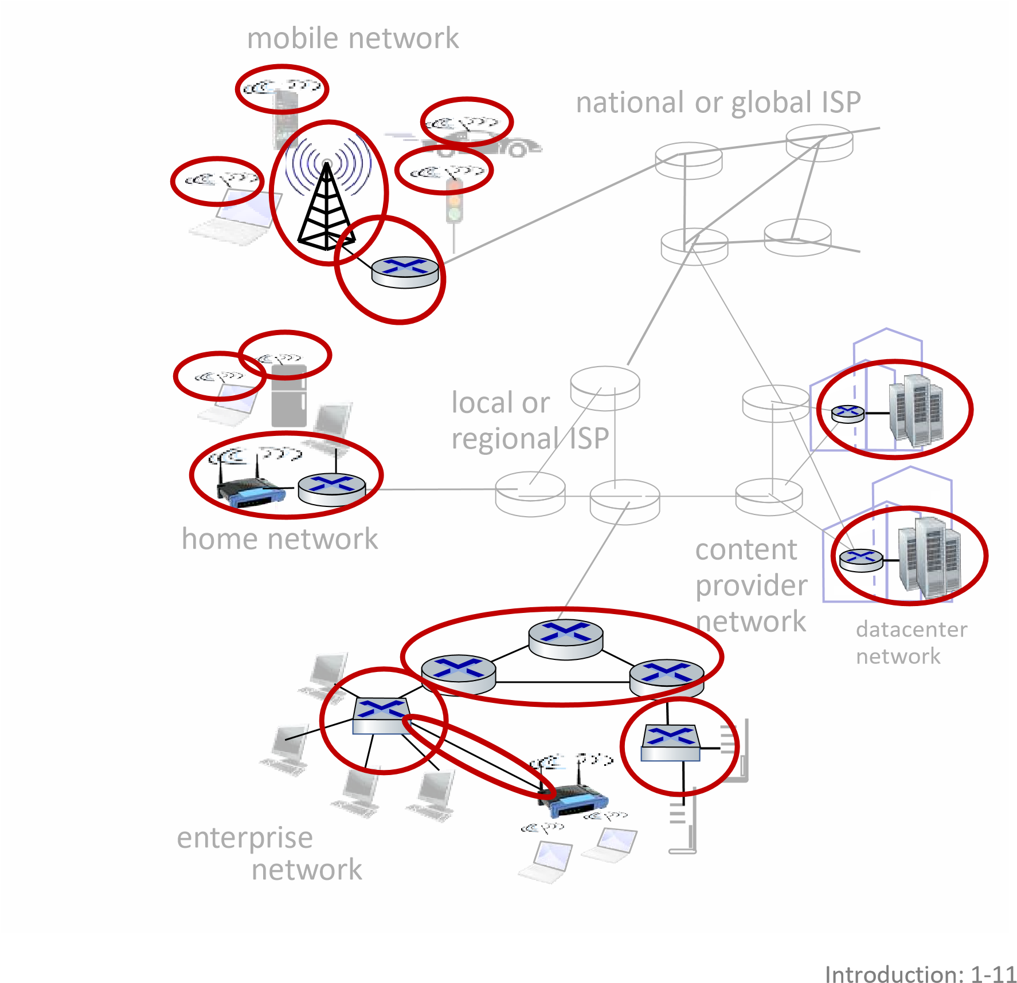
- servers often in data centers
Access networks, physical media:
▪wired, wireless communication links
Network edge:
- hosts: clients and servers
- servers often in data centers
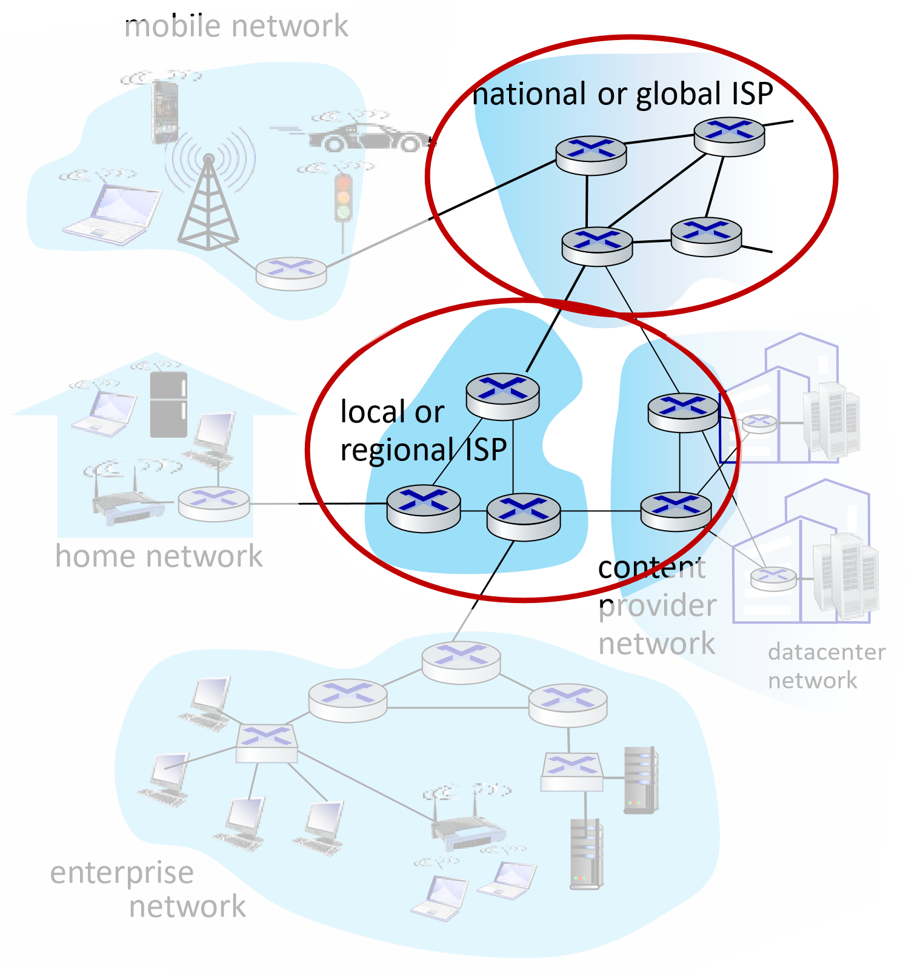
Access networks, physical media: ▪wired, wireless communication links
Network core:
▪interconnected routers
▪network of networks

Access networks and physical media
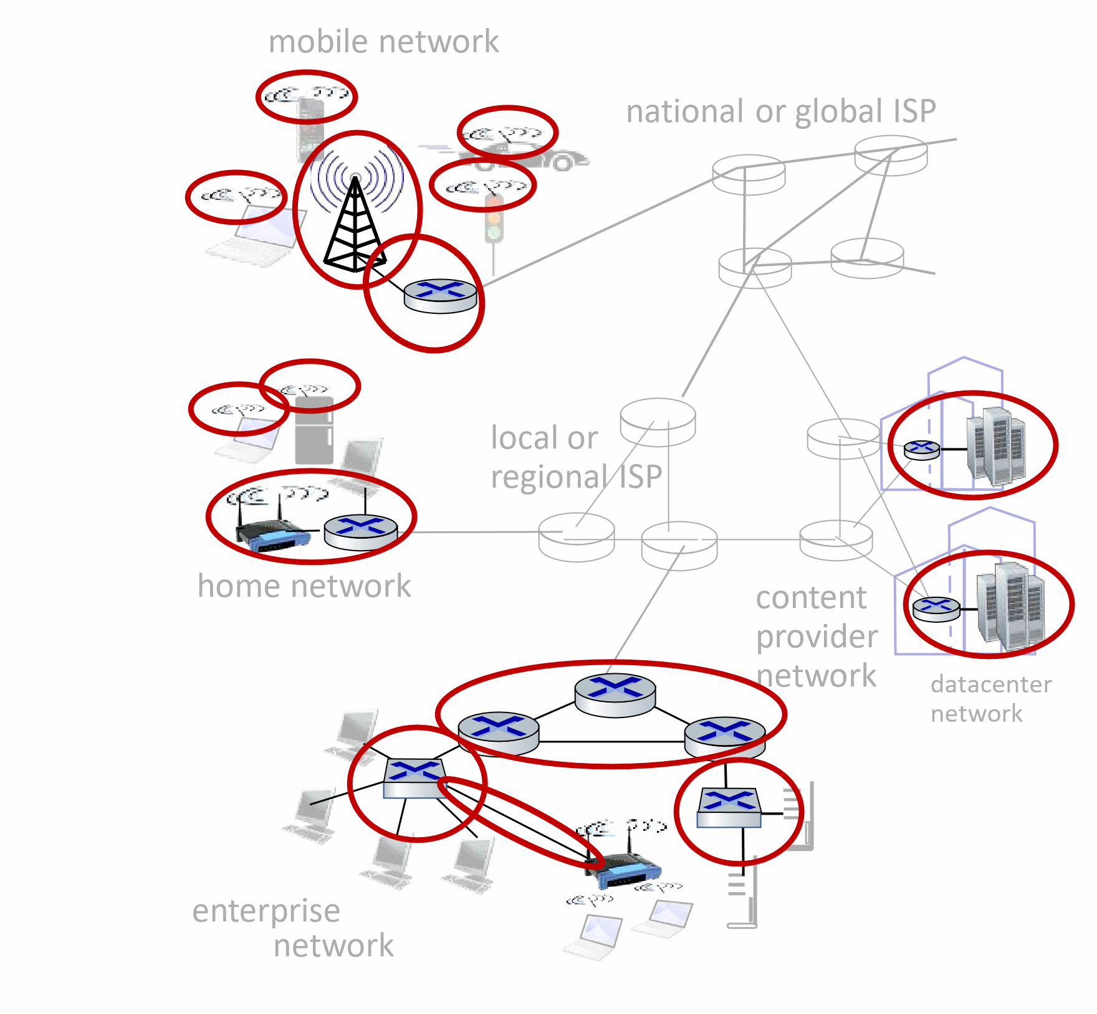
Q: How to connect end systems to edge router?
- residential access nets
- institutional access networks (school, company)
- mobile access networks (WiFi, 4G/5G)

Access networks: cable-based access
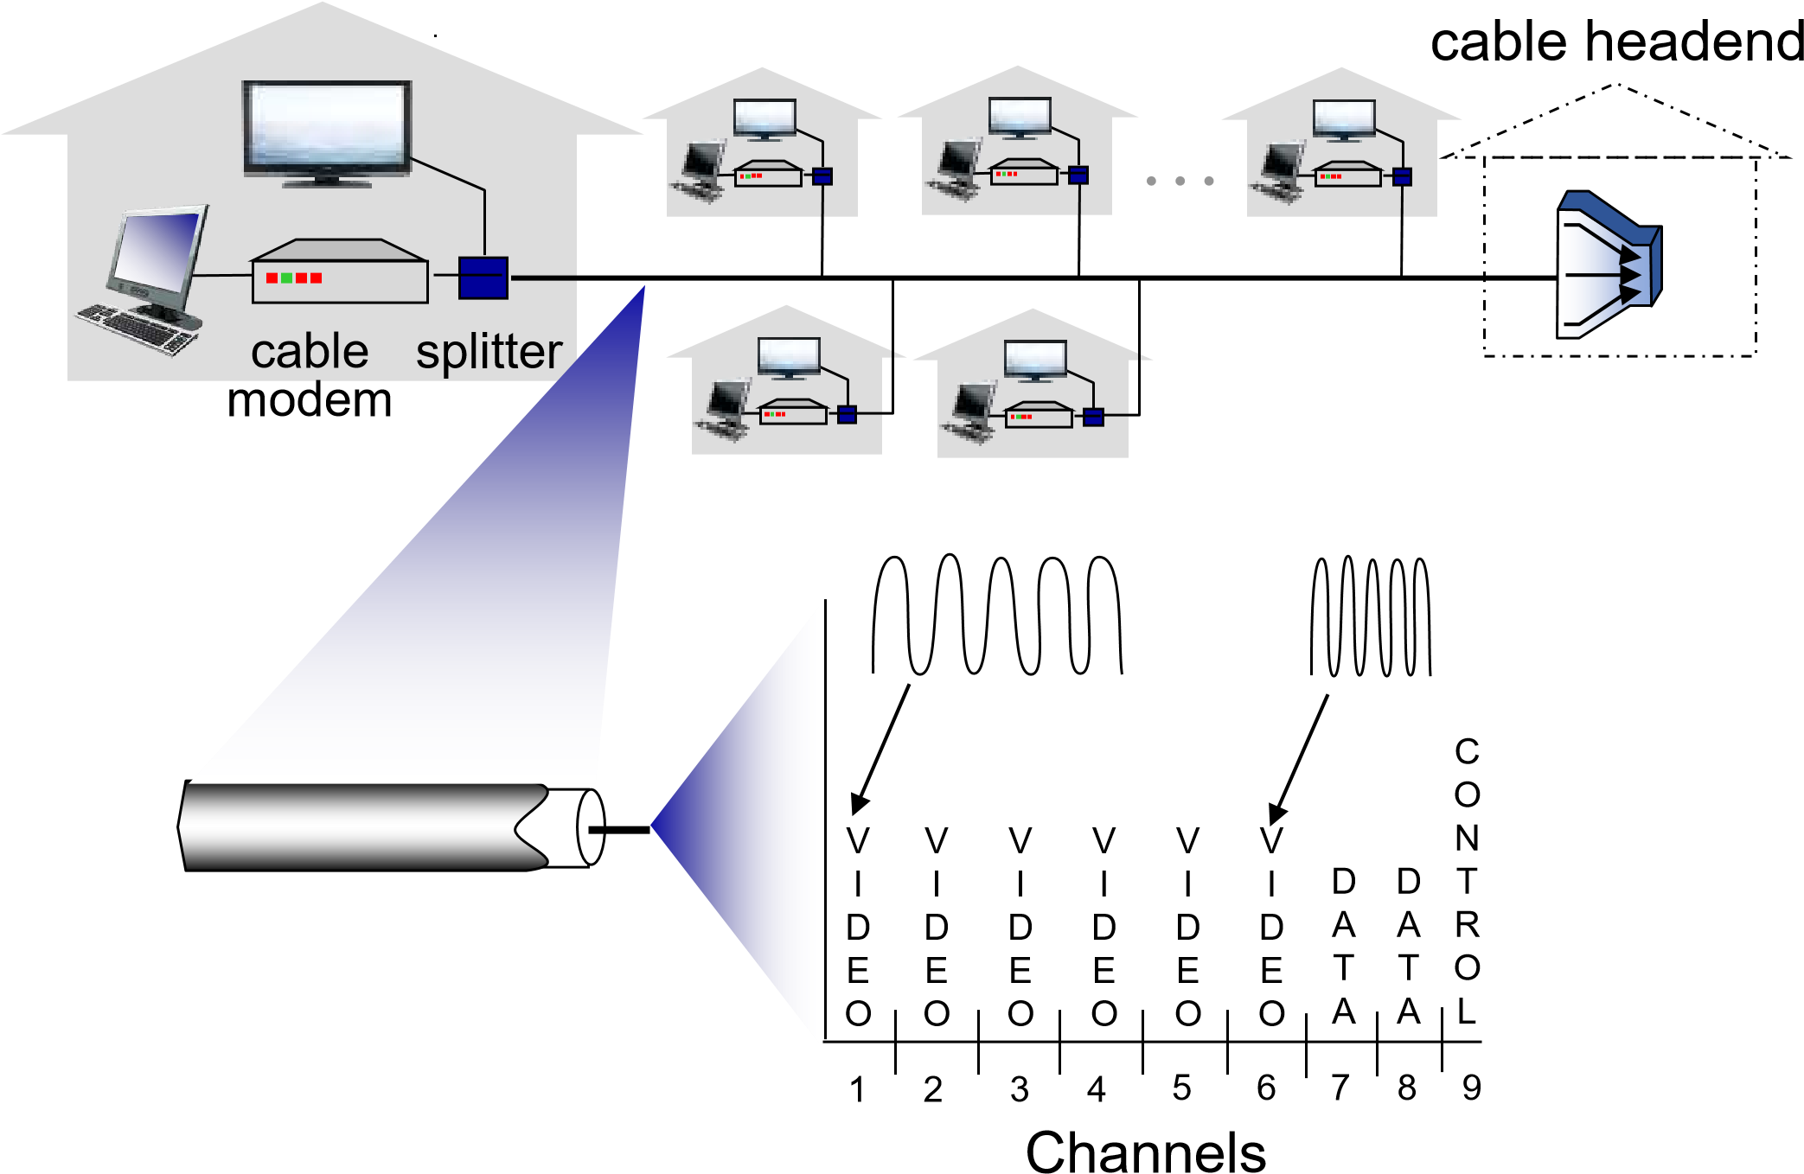
frequency division multiplexing (FDM): different channels transmitted in different frequency bands

Access networks: cable-based access
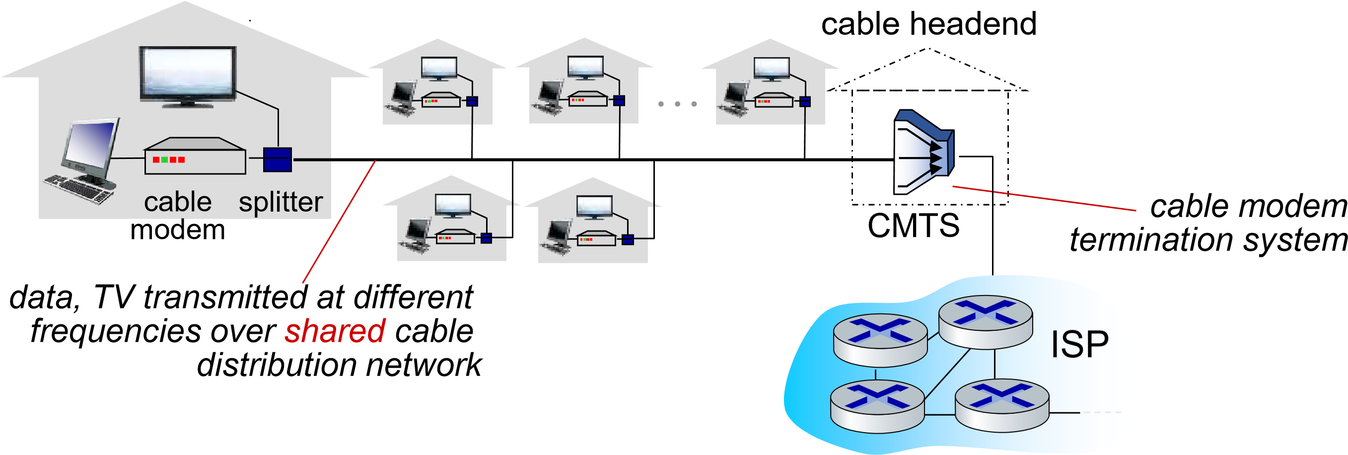
- HFC: hybrid fiber coax
  - asymmetric: up to 40 Mbps – 1.2 Gbps downstream transmission rate, 30-100 Mbps upstream transmission rate
- network of cable, fiber attaches homes to ISP router
  - homes share access network to cable headend

Access networks: digital subscriber line (DSL)

ISP
central office
telephone
network
DSLAM
voice, data transmitted
at different frequencies over
dedicated
line to central office
DSL
modem
splitter
DSL access
multiplexer
- use existing telephone line to central office DSLAM
  - data over DSL phone line goes to Internet
  - voice over DSL phone line goes to telephone net
- 24-52 Mbps dedicated downstream transmission rate
- 3.5-16 Mbps dedicated upstream transmission rate

Access networks: home networks

to/from headend or
central office
cable or DSL modem
router, firewall, NAT
wired Ethernet (

1
Gbps)
WiFi wireless access
point (
54
,

450
Mbps)
Wireless and wired
devices
often combined
in single box
Introduction: 1-17

Wireless access networks
Shared wireless access network connects end system to router

- via base station aka “access point”
Wireless local area networks
(WLANs)
- typically within or around building (~100 ft)
- 802.11b/g/n (WiFi): 11, 54, 450 Mbps transmission rate
to Internet
Wide-area cellular access networks
- provided by mobile, cellular network operator (10’s km)
- 10’s Mbps
- 4G/5G cellular networks
to Internet

Access networks: enterprise networks
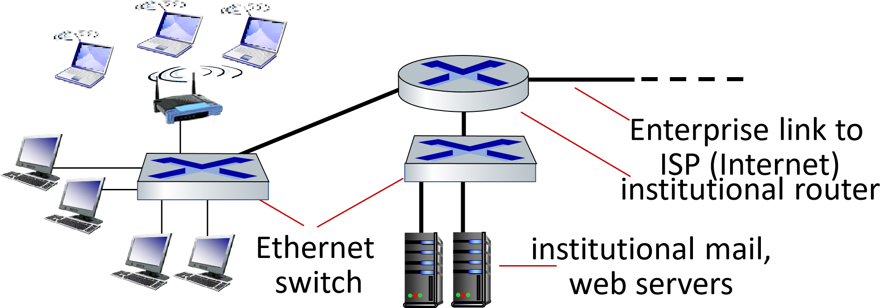
- companies, universities, etc.
- mix of wired, wireless link technologies, connecting a mix of switches and routers (we’ll cover differences shortly)
- Ethernet: wired access at 100Mbps, 1Gbps, 10Gbps
- WiFi: wireless access points at 11, 54, 450 Mbps

Access networks: data center networks
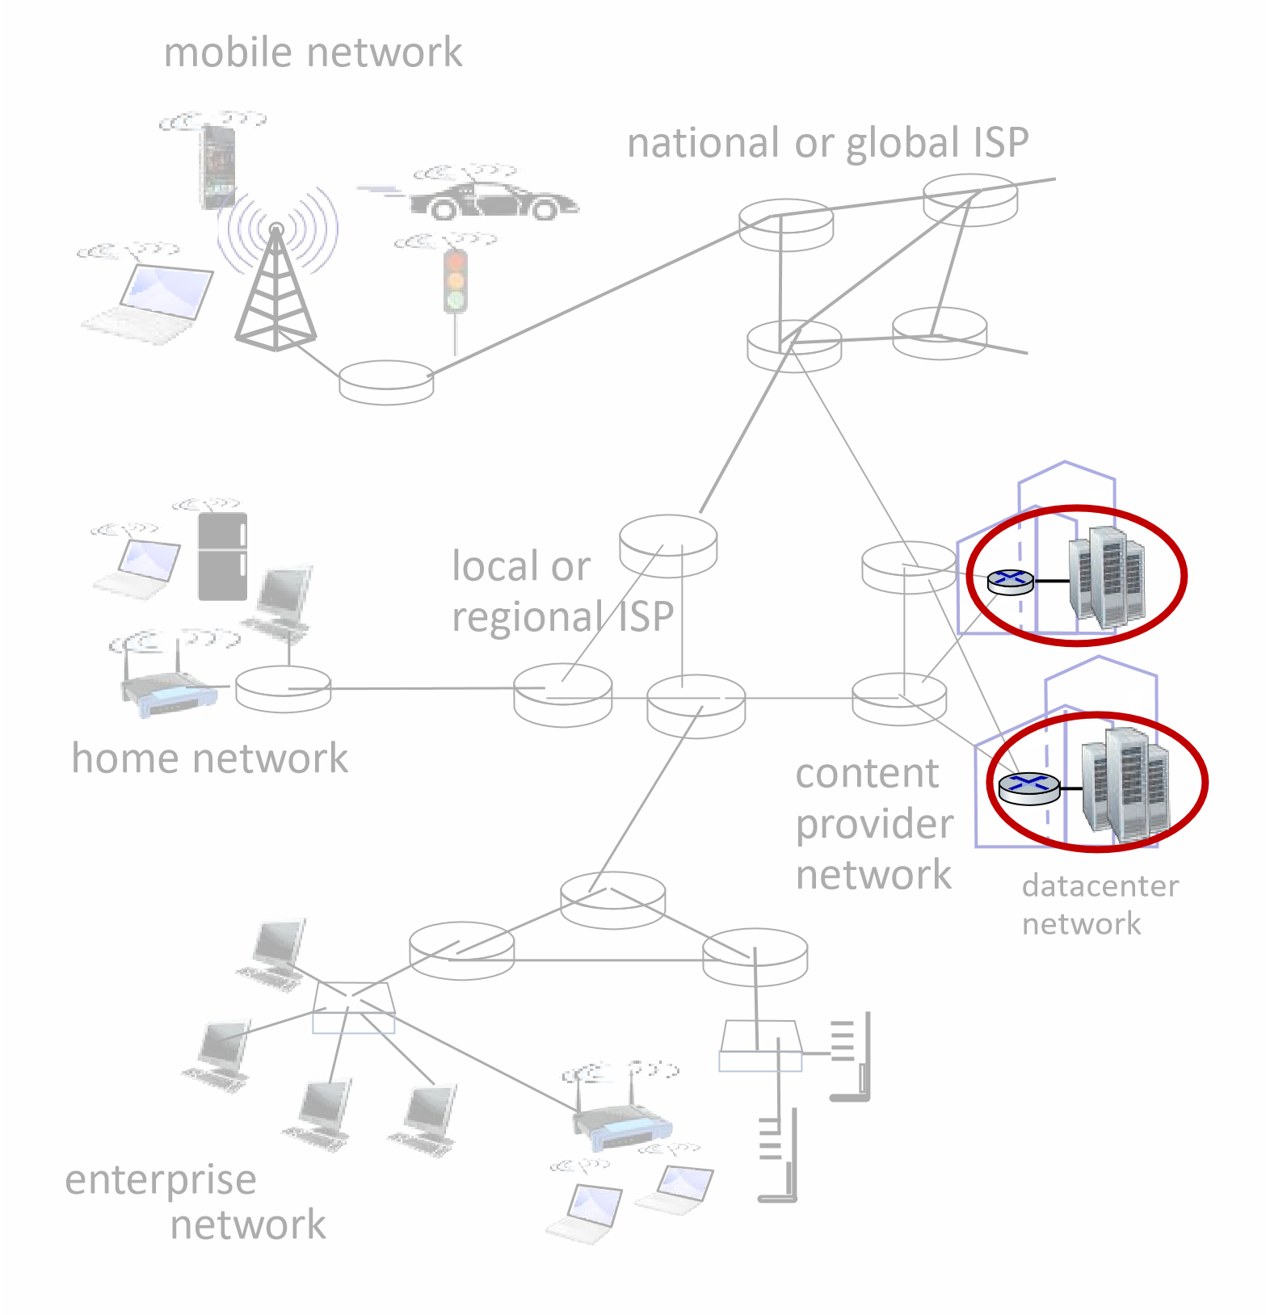
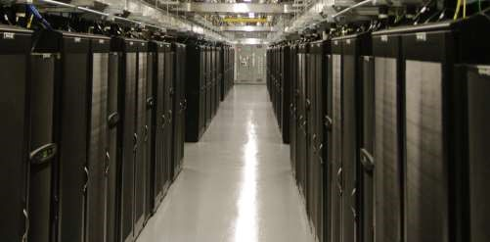
▪ high-bandwidth links (10s to 100s Gbps) connect hundreds to thousands of servers together, and to Internet
Courtesy: Massachusetts Green High Performance Computing Center (mghpcc.org)

Host: sends packets of data
host sending function:
- takes application message






- breaks into smaller chunks, known as packets, of length L bits
host
1
2
two packets,
L
bits each
- transmits packet into access network at transmission rate R
  - link transmission rate, aka link
capacity, aka link bandwidth R: link transmission rate
^{transmission}packet = time needed totransmit L-bit = L (bits)
delay _{packet into link} R (bits/sec)

- bit: propagates between transmitter/receiver pairs
- physical link: what lies between transmitter & receiver
- guided media:
  - signals propagate in solid media: copper, fiber, coax
- unguided media:
  - signals propagate freely,
e.g., radio
Twisted pair (TP)
- two insulated copper wires
  - Category 5: 100 Mbps, 1 Gbps Ethernet • Category 6: 10Gbps Ethernet
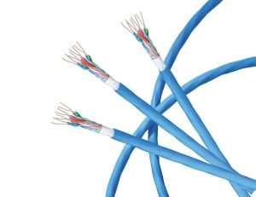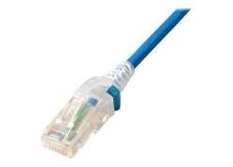
Introduction: 1-22
Coaxial cable:
- two concentric copper conductors
- bidirectional ▪ broadband:
  - multiple frequency channels on cable
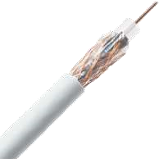• 100’s Mbps per channel
Fiber optic cable:
- glass fiber carrying light pulses, each pulse a bit
- high-speed operation:
  - high-speed point-to-point transmission (10’s-100’s Gbps) ▪ low error rate:
  - repeaters spaced far apart
  - immune to electromagnetic noise
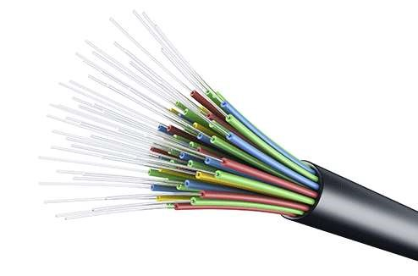
Wireless radio
- signal carried in various “bands” in electromagnetic spectrum
- no physical “wire” ▪ broadcast, “half-duplex”
(sender to receiver)
- propagation environment effects:
  - reflection
  - obstruction by objects
  - Interference/noise
Radio link types:
- Wireless LAN (WiFi)
  - 10-100’s Mbps; 10’s of meters
- wide-area (e.g., 4G/5G cellular)
  - 10’s Mbps (4G) over ~10 Km
- Bluetooth: cable replacement
  - short distances, limited rates
- terrestrial microwave
  - point-to-point; 45 Mbps channels
- satellite
  - up to < 100 Mbps (Starlink) downlink
  - 270 msec end-end delay (geostationary)
Introduction: 1-24

Chapter 1: roadmap
- What is the Internet?
- What is a protocol?
- Network edge: hosts, access network, physical media
- Network core: packet/circuit switching, internet structure
- Performance: loss, delay, throughput
- Security
- Protocol layers, service models
- History

The network core
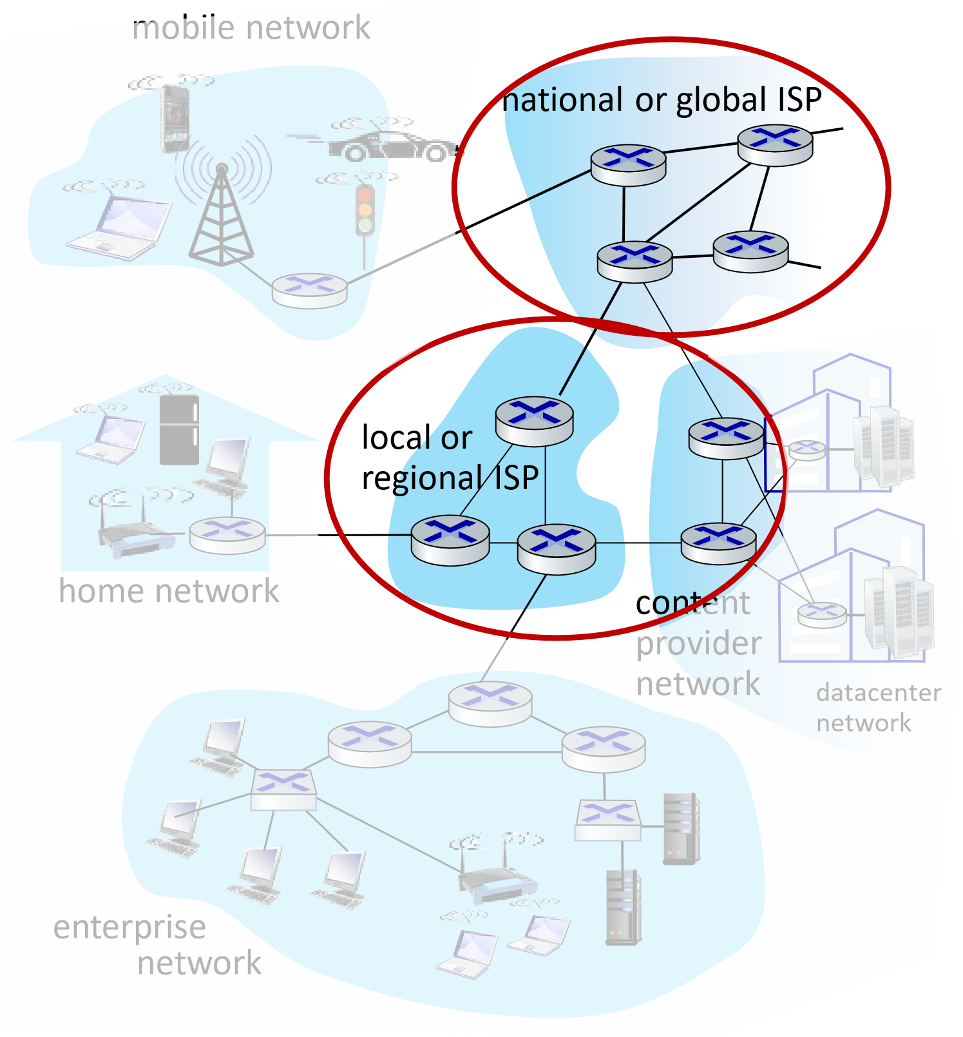
- mesh of interconnected routers
- packet-switching: hosts break application-layer messages into packets
• network forwards packets from one router to the next, across links on path from source to destination

Two key network-core functions
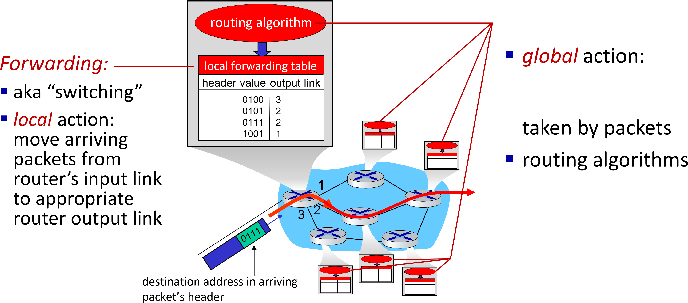
Routing:
determine sourcedestination paths
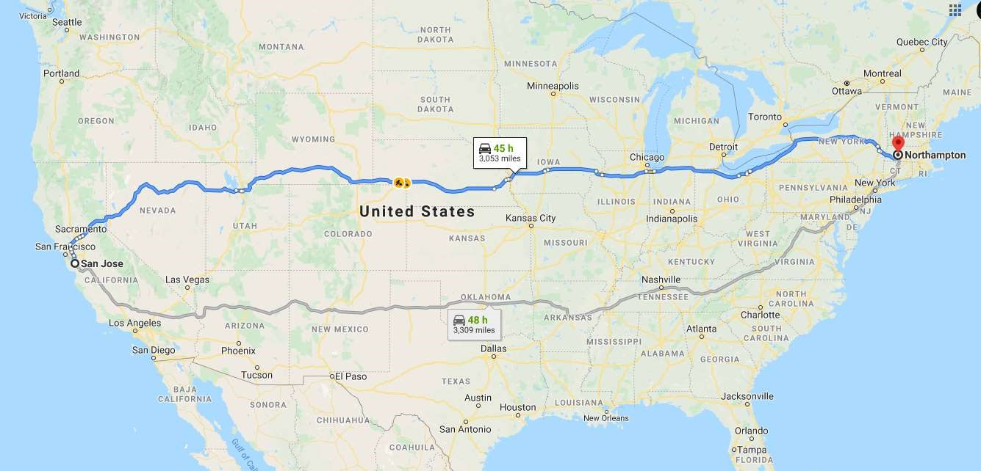
routing
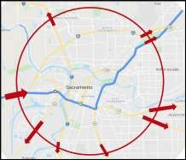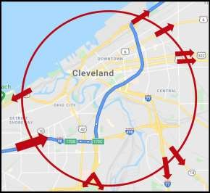
forwarding
forwarding

switching: store-and-forward

source
R
bps
destination
1
2
3
L
bits
per packet
R
bps
- packet transmission delay: takes L/R seconds to transmit (push out) L-bit packet into link at R bps
One-hop numerical example:
- L = 10 Kbits
- R = 100 Mbps
- one-hop transmission delay = 0.1 msec
- store and forward: entire packet must arrive at router before it can be transmitted on next link

switching: queueing

A
B
C
R
100 Mb/s
=
R
1.5 Mb/s
=
D
E
queue
of packets
waiting for transmission
over output link
Queueing occurs when work arrives faster than it can be serviced:


switching: queueing
A
B
C
R
=

100

Mb/s
R
=

1.5

Mb/s
D
E
queue
of packets
waiting for transmission
over output link
Packet queuing and loss: if arrival rate (in bps) to link exceeds transmission rate (bps) of link for some period of time:
- packets will queue, waiting to be transmitted on output link
- packets can be dropped (lost) if memory (buffer) in router fills up
Alternative to packet switching: circuit switching
end-end resources allocated to,
reserved for “call” between source and destination
- in diagram, each link has four circuits.
  - call gets 2nd circuit in top link and 1st circuit in right link.
- dedicated resources: no sharing
  - circuit-like (guaranteed) performance
- circuit segment idle if not used by call (no sharing)







- commonly used in traditional telephone networks
* Check out the online interactive exercises for more examples: http://gaia.cs.umass.edu/kurose_ross/interactive

Circuit switching: FDM and TDM
Frequency Division Multiplexing
(FDM) 4 users
- optical, electromagnetic frequencies divided into (narrow) frequency bands
frequency
- each call allocated its own band, can
transmit at max rate of that narrow band | time
Time Division Multiplexing (TDM)
frequency
- time divided into slots
- each call allocated periodic slot(s), can
transmit at maximum rate of (wider) time frequency band (only) during its time slot(s)

Packet switching versus circuit switching



example:
N
users
1

Gbps link
- 1 Gb/s link ▪ each user:
  - 100 Mb/s when “active”
  - active 10% of time
Q: how many users can use this network under circuit-switching and packet switching?
- circuit-switching: 10 users
- packet switching: with 35 users, Q: how did we get value 0.0004? probability > is less than .000410 active at same time * A: HW problem _{(for those with}
course in probability only)
* Check out the online interactive exercises for more examples: http://gaia.cs.umass.edu/kurose_ross/interactive

Packet switching versus circuit switching
Is packet switching a “slam dunk winner”?
- great for “bursty” data – sometimes has data to send, but at other times not • resource sharing
  - simpler, no call setup
- excessive congestion possible: packet delay and loss due to buffer overflow
  - protocols needed for reliable data transfer, congestion control
- Q: How to provide circuit-like behavior with packet-switching?
  - “It’s complicated.” We’ll study various techniques that try to make packet switching as “circuit-like” as possible.
Q: human analogies of reserved resources (circuit switching) versus on-demand allocation (packet switching)?
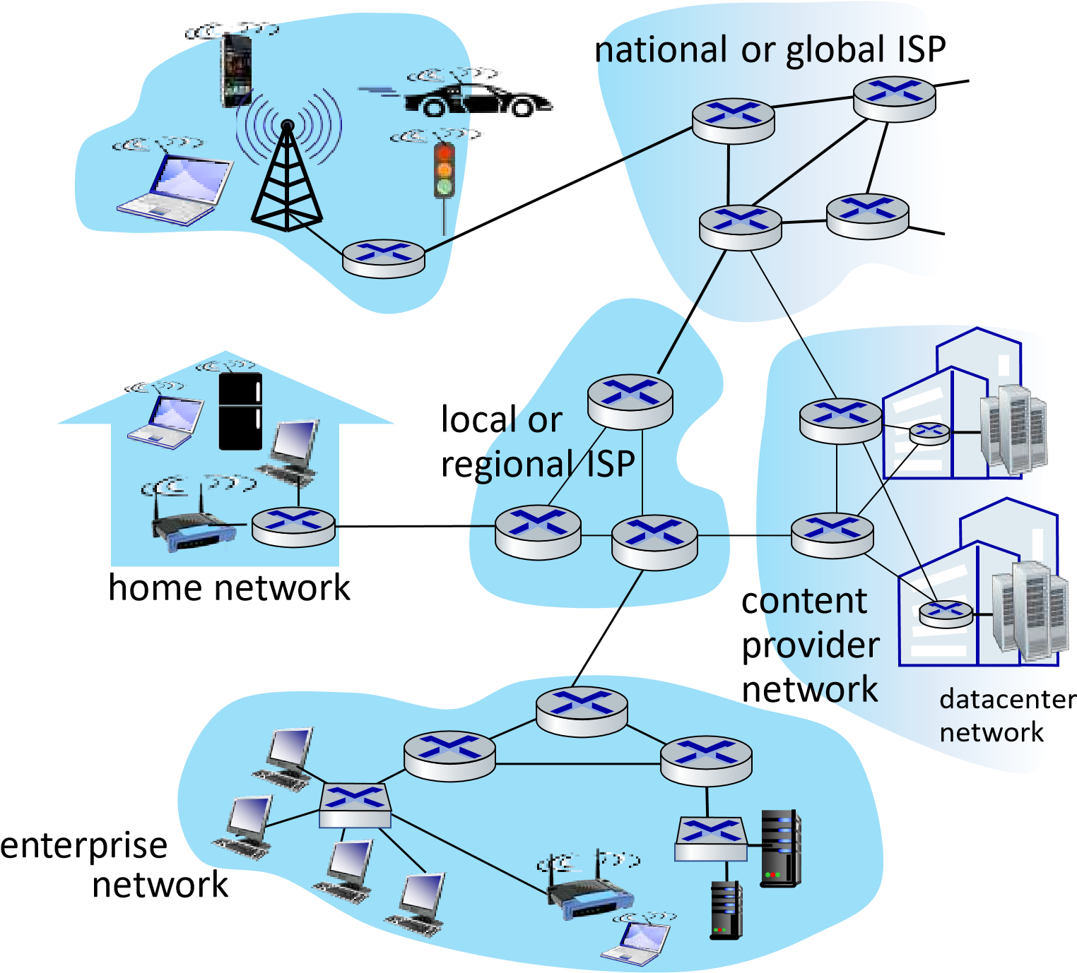
- hosts connect to Internet via access ^{mobile network}
Internet Service Providers (ISPs)
- access ISPs in turn must be interconnected
  - so that any two hosts (anywhere!) can send packets to each other
- resulting network of networks is very complex
  - evolution driven by economics, national policies

Let’s take a stepwise approach to describe current Internet structure
Question: given millions of access ISPs, how to connect them together?
access
net
access
net
access
net
access
net
access
net
access
net
access
net
access
net
access
net
access
net
access
net
access
net
Question: given millions of access ISPs, how to connect them together?
access
net
access
net
access
net
access
net
access
net
s
acces
net
access
net
access
net
access
net
access
net
access
net
access
net
connecting each access ISP to
each other directly
doesn
’
t scale:
O(
N
2
)
connections.
Option: connect each access ISP to one global transit ISP? Customer and provider ISPs have economic agreement.

global
ISP
access
net
access
net
access
net
access
net
access
net
access
net
access
net
access
net
access
net
access
net
access
net
access
net

Internet structure: a “network of networks”
But if one global ISP is viable business, there will be competitors ….
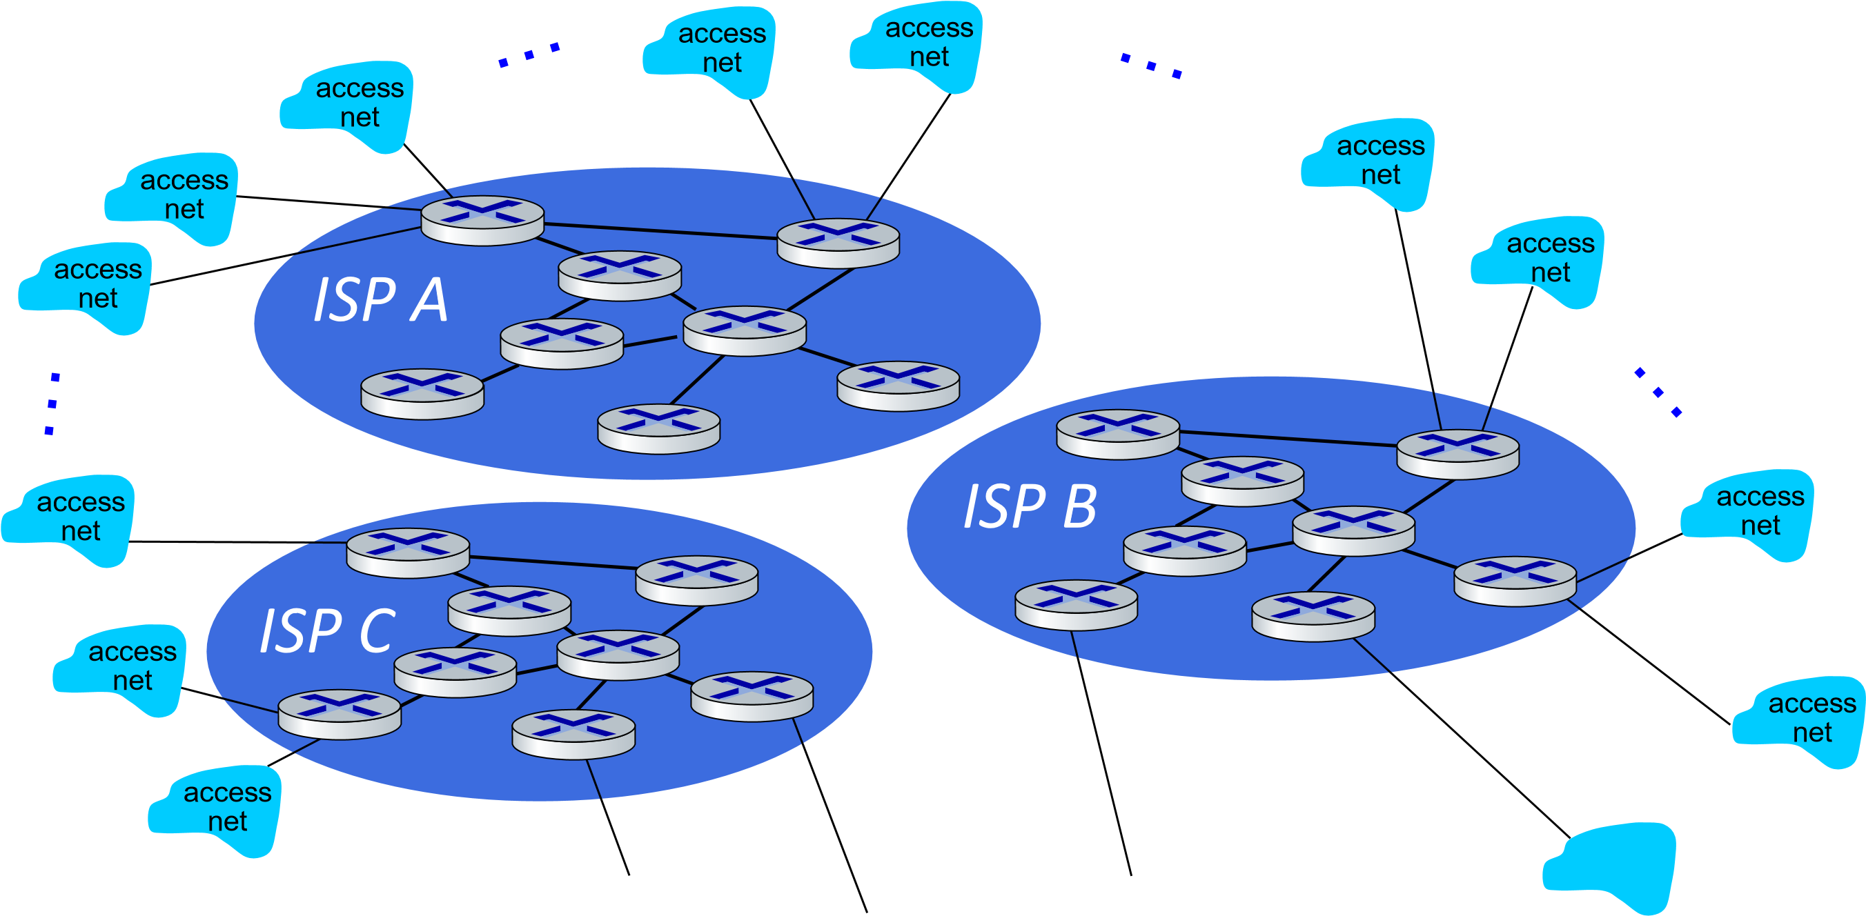
But if one global ISP is viable business, there will be competitors …. who will
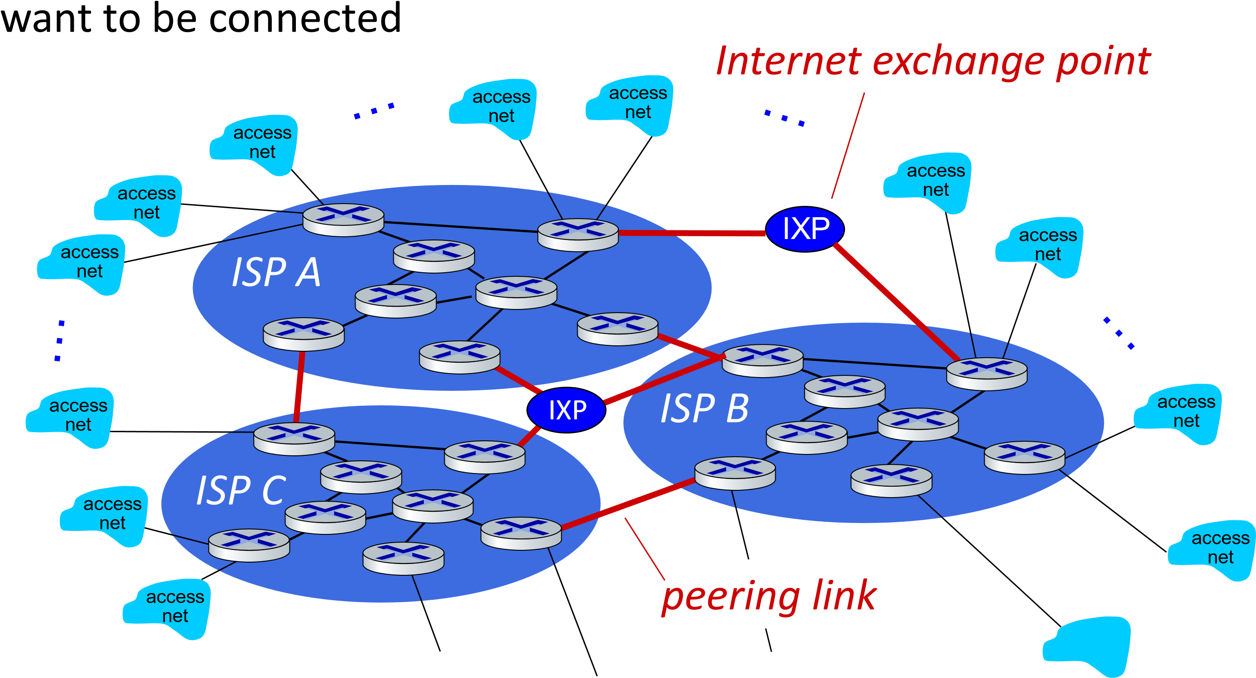
… and regional networks may arise to connect access nets to ISPs
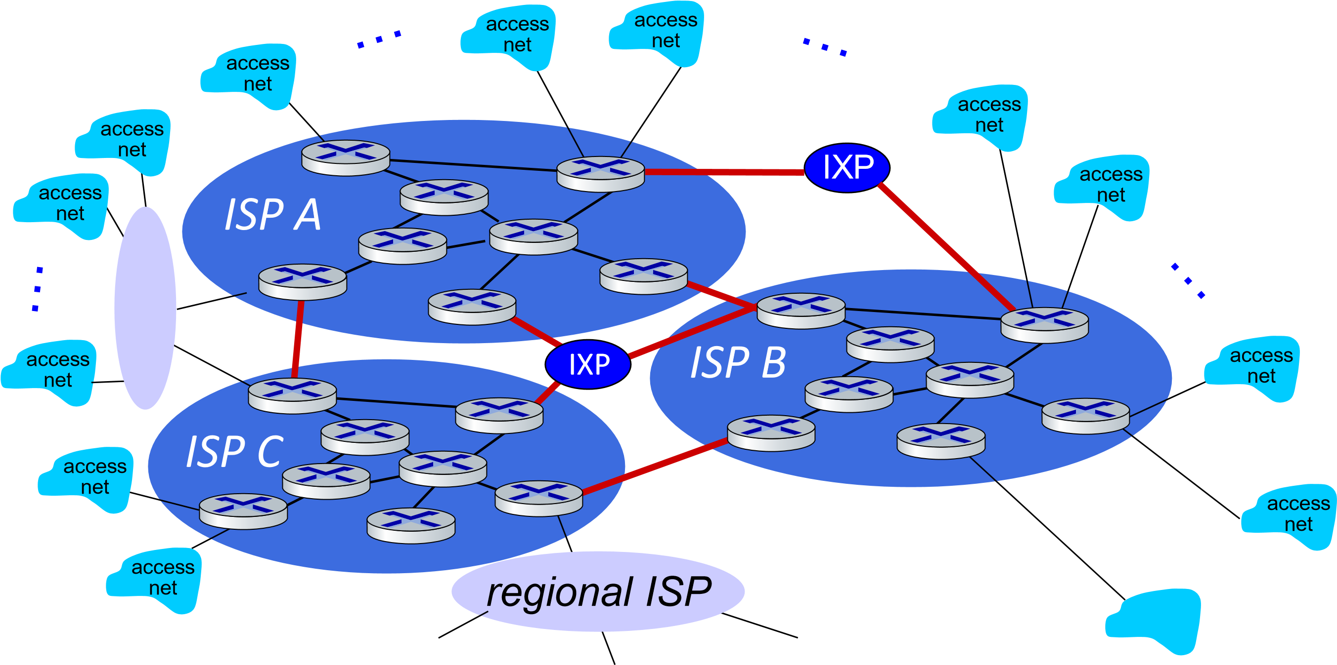
Introduction: 1-43
… and content provider networks (e.g., Google, Microsoft, Akamai) may run their own network, to bring services, content close to end users
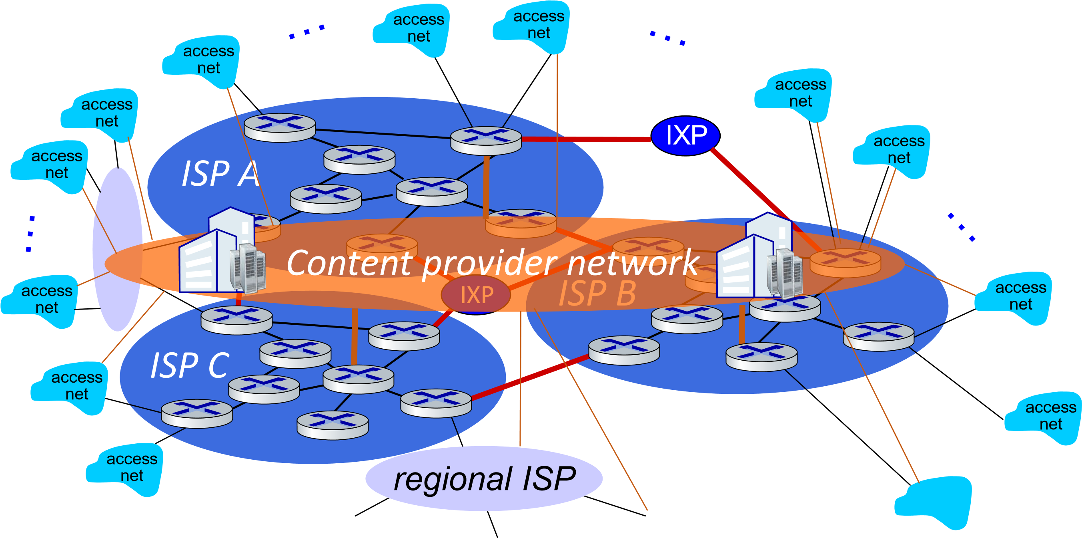
access
ISP
access
ISP
access
ISP
access
ISP
access
ISP
access
ISP
access
ISP
access
ISP
Regional ISP
Regional ISP
Tier
1

ISP
Tier 1 ISP
IXP
Google
IXP
IXP
At “center”: small # of well-connected large networks
- “tier-1” commercial ISPs (e.g., Level 3, Sprint, AT&T, NTT), national & international coverage
- content provider networks (e.g., Google, Facebook): private network that connects its
data centers to Internet, often bypassing tier-1, regional ISPs

Chapter 1: roadmap
- What is the Internet?
- What is a protocol?
- Network edge: hosts, access network, physical media
- Network core: packet/circuit switching, internet structure
- Performance: loss, delay, throughput
- Security
- Protocol layers, service models
- History
Introduction: 1-46
How do packet delay and loss occur?
- packets queue in router buffers, waiting for turn for transmission
- queue length grows when arrival rate to link (temporarily) exceeds output link capacity
- packet loss occurs when memory to hold queued packets fills up




packet being transmitted (transmission delay) free (available) buffers: arriving packets dropped (loss) if no free buffers
A
B
packets in buffers
)
(
queueing delay

Packet delay: four sources

propagation
nodal
processing
queueing
A
B
transmission
dnodal = dproc + dqueue + dtrans + dprop

d_{proc}: nodal processing
- check bit errors
- determine output link
- typically < microsecs
d_{queue}: queueing delay
- time waiting at output link for transmission
- depends on congestion level of router
d_{trans}: transmission delay:
Packet delay: four sources

dnodal = dproc + dqueue + dtrans + dprop
propagation
nodal
processing
queueing
A
B
transmission
- L: packet length (bits)
- R: link transmission rate (bps)
- d_{trans} = L/R
dtrans and dprop very different
d_{prop}: propagation delay:
- d: length of physical link
- s: propagation speed (~2x10⁸ m/sec)
▪
d
prop
=

d
/
s

Caravan analogy
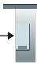 100 km 100 km
ten-car caravan toll booth toll booth toll booth
(aka 10-bit packet) (aka link)
- car ~ bit; caravan ~ packet; toll ▪ time to “push” entire caravan service ~ link transmission through toll booth onto
- toll booth takes 12 sec to service highway = 12*10 = 120 sec car (bit transmission time) ▪ time for last car to propagate
- “propagate” at 100 km/hr from 1st to 2nd toll both:
100km/(100km/hr) = 1 hr ▪ Q: How long until caravan is lined
up before 2nd toll booth? ▪ A: 62 minutes
Introduction: 1-50

Caravan analogy
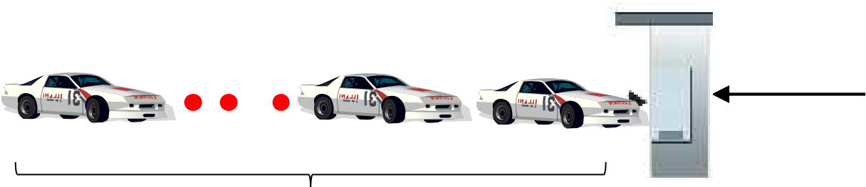 100 km 100 km
ten-car caravan toll booth toll booth
(aka 10-bit packet) (aka router)
- suppose cars now “propagate” at 1000 km/hr
- and suppose toll booth now takes one min to service a car
- Q: Will cars arrive to 2nd booth before all cars serviced at first booth? A: Yes! after 7 min, first car arrives at second booth; three cars still at first booth
Introduction: 1-51

Packet queueing delay (revisited)
- a: average packet arrival rate
average queueing delay
- L: packet length (bits)
- R: link bandwidth (bit transmission rate)
L . a : arrival rate of bits “traffic
R service rate of bits intensity”
traffic intensity = La/R | 1
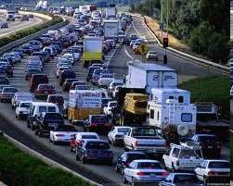

- La/R ~ 0: avg. queueing delay small
La/R
~
0
- La/R -> 1: avg. queueing delay large
- La/R > 1: more “work” arriving is more than can be serviced - average delay infinite!
La/R -> 1

“Real” Internet delays and routes
- what do “real” Internet delay & loss look like?
- traceroute program: provides delay measurement from source to router along end-end Internet path towards destination. For all i:
  - sends three packets that will reach router i on path towards destination (with time-to-live field value of i)
  - router i will return packets to sender
  - sender measures time interval between transmission and reply

3

probes
3

probes
3

probes
Introduction: 1-53

Real Internet delays and routes
traceroute: gaia.cs.umass.edu to www.eurecom.fr
3 delay measurements from gaia.cs.umass.edu to cs-gw.cs.umass.edu
12 csborder-gw 1(128.119.240.254-rt-fa5-1-0.gw.umass.edu) 1 ms 1 ( ms 128.119.3.1452 ms ) 1 ms 1 ms 2 ms 3 delay measurements
- cht-vbns.gw.umass.edu (128.119.3.130) 6 ms 5 ms 5 ms to border1-rt-fa5-1-0.gw.umass.edu
- jn1-at1-0-0-19.wor.vbns.net (204.147.132.129) 16 ms 11 ms 13 ms 5 jn1-so7-0-0-0.wae.vbns.net (204.147.136.136) 21 ms 18 ms 18 ms
- abilene-vbns.abilene.ucaid.edu (198.32.11.9) 22 ms 18 ms 22 ms
- nycm-wash.abilene.ucaid.edu (198.32.8.46) 22 ms 22 ms 22 ms trans-oceanic link
- 62.40.103.253 (62.40.103.253) 104 ms 109 ms 106 ms
- de2-1.de1.de.geant.net (62.40.96.129) 109 ms 102 ms 104 ms
1011 renaterde.fr1.fr.geant.net (-gw.fr1.fr.geant.net (62.40.96.5062.40.103.54) 113 ms )121 112 ms ms 114114 ms ms 112 ms _{looks like delays}
- nio-n2.cssi.renater.fr (193.51.206.13) 111 ms 114 ms 116 ms decrease! Why?
- nice.cssi.renater.fr (195.220.98.102) 123 ms 125 ms 124 ms
- r3t2-nice.cssi.renater.fr (195.220.98.110) 126 ms 126 ms 124 ms
- eurecom-valbonne.r3t2.ft.net (193.48.50.54) 135 ms 128 ms 133 ms 16 194.214.211.25 (194.214.211.25) 126 ms 128 ms 126 ms
- * * *
- * * ** means no response (probe lost, router not replying)
- fantasia.eurecom.fr (193.55.113.142) 132 ms 128 ms 136 ms
* Do some traceroutes from exotic countries at www.traceroute.org

Packet loss
- queue (aka buffer) preceding link in buffer has finite capacity
- packet arriving to full queue dropped (aka lost)
- lost packet may be retransmitted by previous node, by source end system, or not at all
buffer

A
B
packet being transmitted
(
waiting area
)
packet arriving to
full buffer is
lost
* Check out the Java applet for an interactive animation (on publisher’s website) of queuing and loss

Throughput
▪ throughput: rate (bits/time unit) at which bits are being sent from sender to receiver
- instantaneous: rate at given point in time
- average: rate over longer period of time
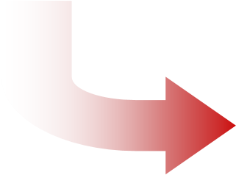
server, with
file of F bits
to send to client
link capacity
R
s
bits/sec
link capacity
R
c
bits/sec
server sends bits
(
fluid) into pipe
pipe that can carry
fluid at rate
(
R
s
bits/sec)
pipe that can carry
fluid at rate
(
R
c
bits/sec)

Throughput
R_{s} < R_{c} What is average end-end throughput?
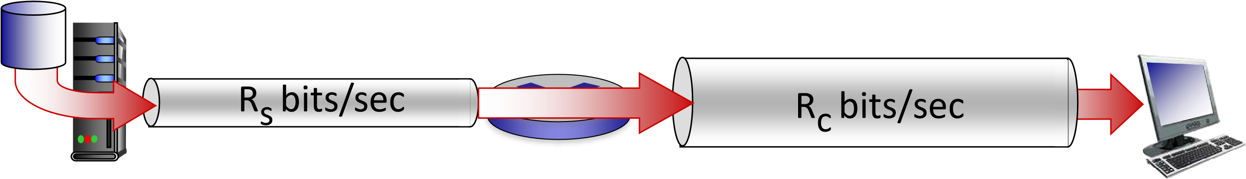
R_{s} > R_{c} What is average end-end throughput?
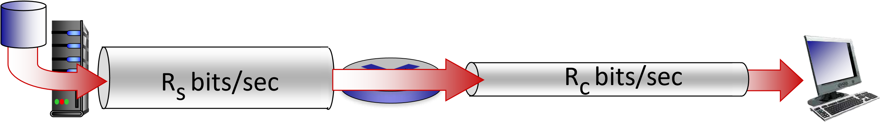
 | bottleneck link | end path that constrains end-end throughput
 | link on end- | end path that constrains end-end throughput

Throughput: network scenario
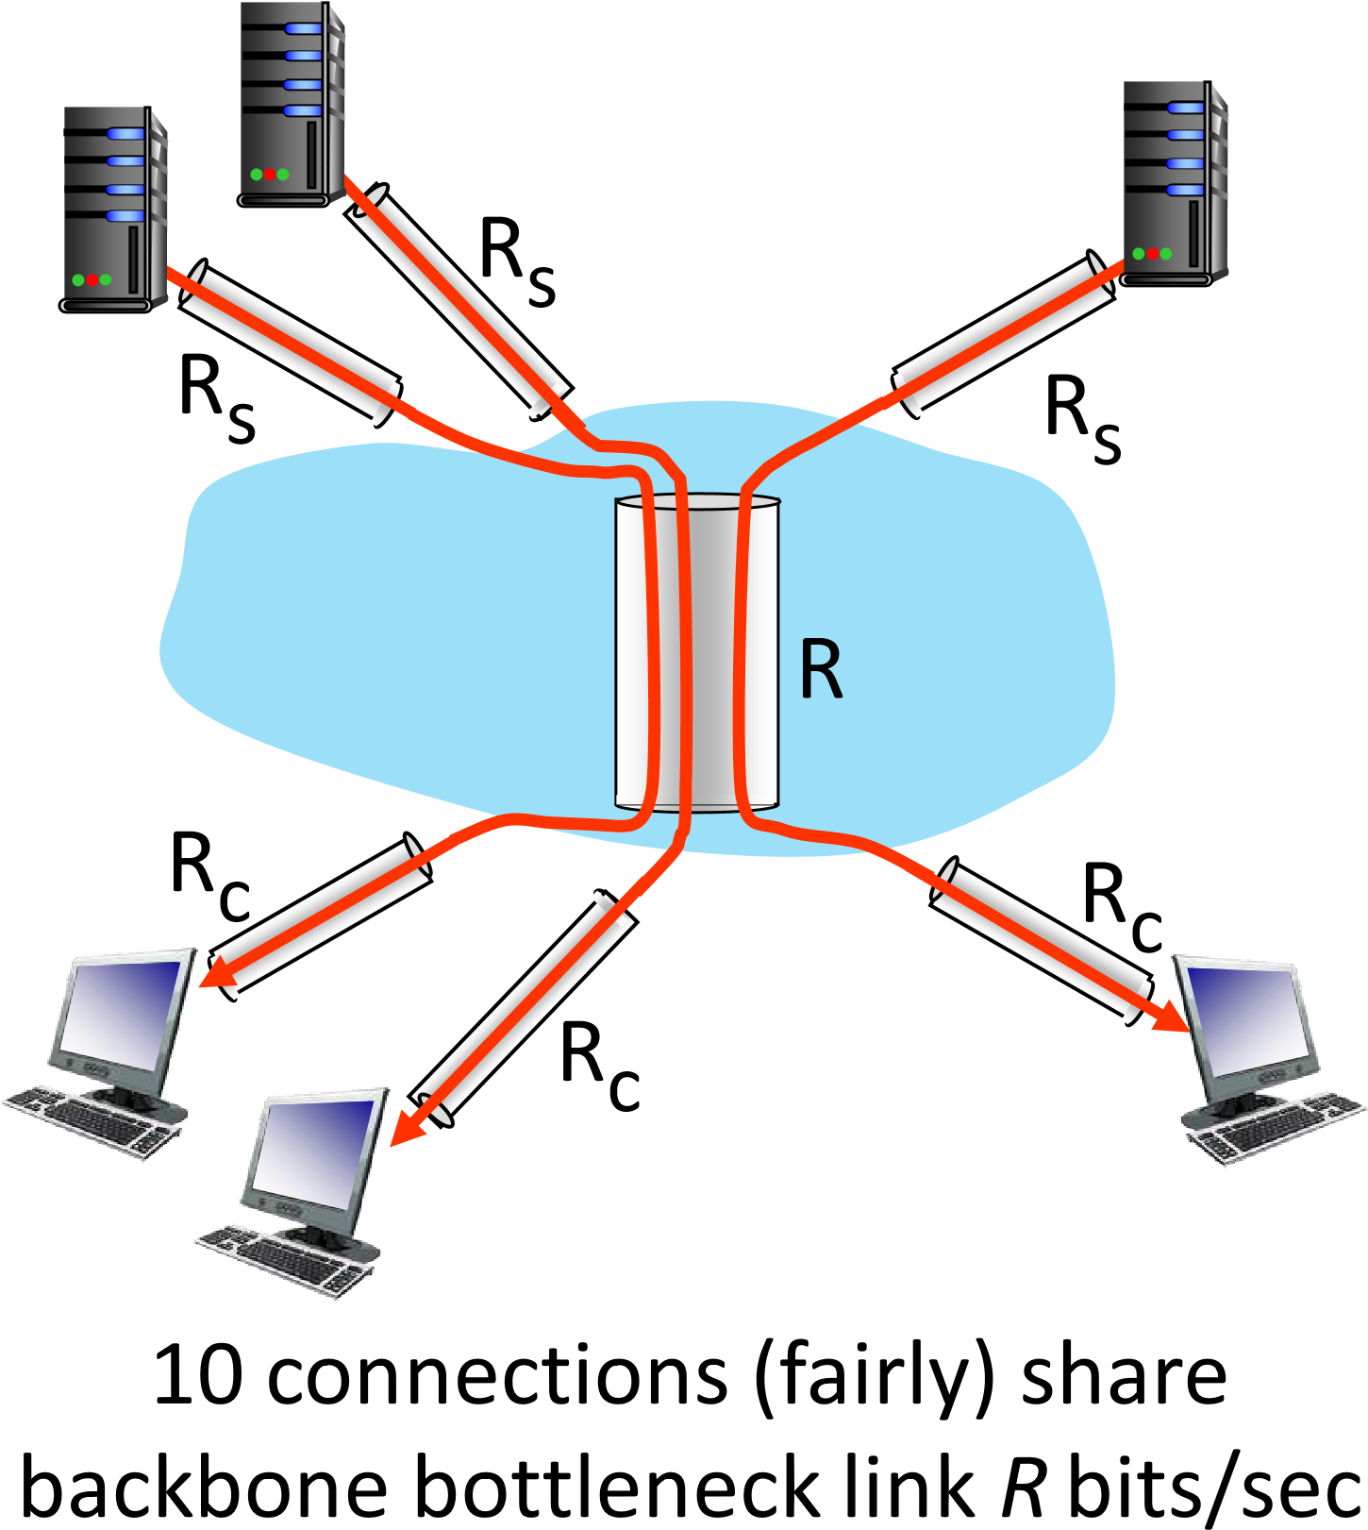
- per-connection endend throughput: min(R_{c},R_{s},R/10)
- in practice: R_{c} or R_{s} is often bottleneck
* Check out the online interactive exercises for more examples: http://gaia.cs.umass.edu/kurose_ross/
Introduction: 1-58

Chapter 1: roadmap
- What is the Internet?
- What is a protocol?
- Network edge: hosts, access network, physical media
- Network core: packet/circuit switching, internet structure
- Performance: loss, delay, throughput
- Security
- Protocol layers, service models
- History
Introduction: 1-59

Network security
- Internet not originally designed with (much) security in mind
  - original vision: “a group of mutually trusting users attached to a transparent network” ☺
  - Internet protocol designers playing “catch-up”
  - security considerations in all layers!
- We now need to think about:
  - how bad guys can attack computer networks
  - how we can defend networks against attacks
  - how to design architectures that are immune to attacks

Network security
- Internet not originally designed with (much) security in mind
  - original vision: “a group of mutually trusting users attached to a transparent network” ☺
  - Internet protocol designers playing “catch-up”
  - security considerations in all layers!
- We now need to think about:
  - how bad guys can attack computer networks
  - how we can defend networks against attacks
  - how to design architectures that are immune to attacks
Introduction: 1-61

Bad guys: packet interception
packet “sniffing”:
- broadcast media (shared Ethernet, wireless)
- promiscuous network interface reads/records all packets (e.g., including passwords!) passing by

A
B
C
src:B dest:A payload
 Wireshark software used for our end-of-chapter labs is a (free) packet-sniffer

Bad guys: fake identity
IP spoofing: injection of packet with false source address




A
C
src:B
dest:A payload
B

Bad guys: denial of service
Denial of Service (DoS): attackers make resources (server, bandwidth) unavailable to legitimate traffic by overwhelming resource with bogus traffic
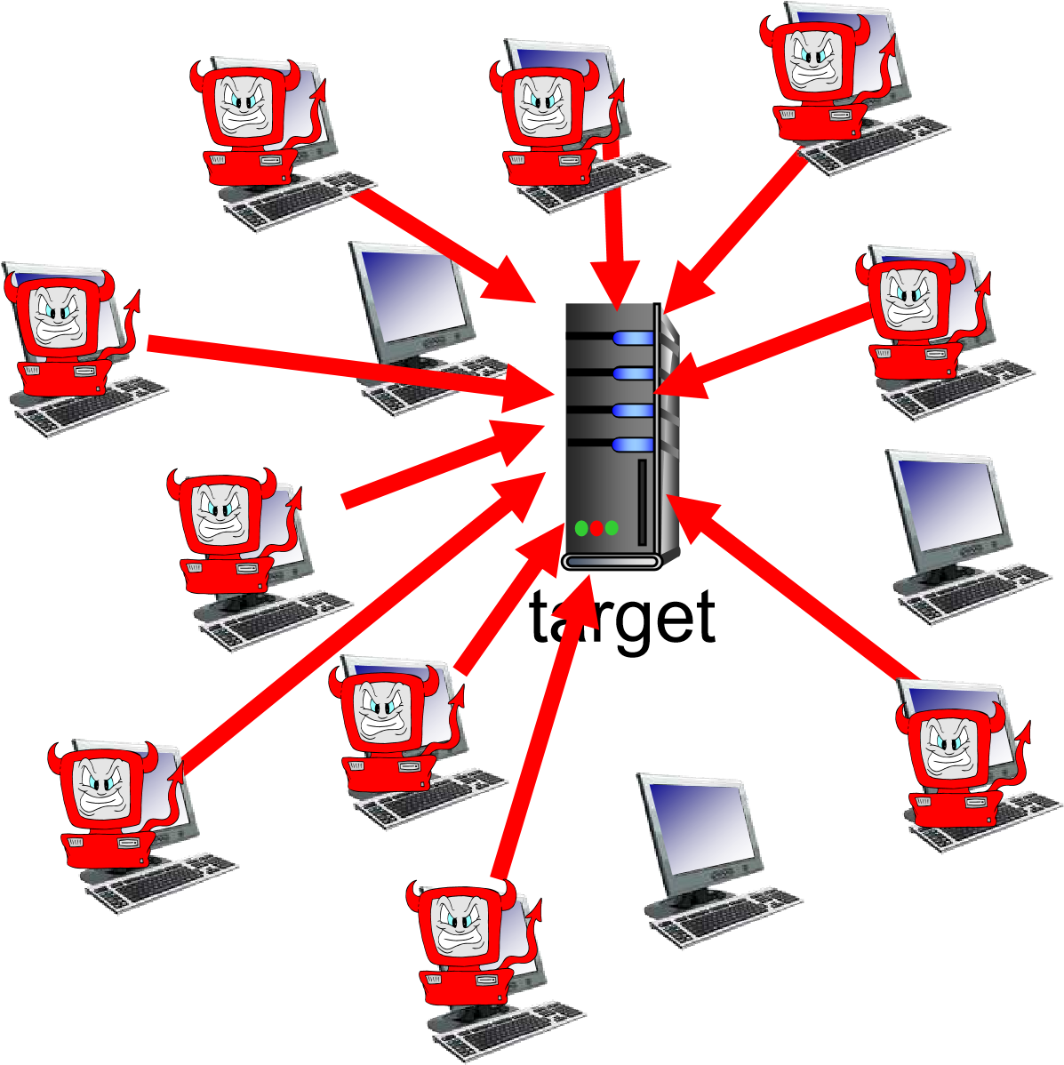
- select target
- break into hosts around the network
(see botnet)
- send packets to target from compromised hosts
Lines of defense:
- authentication: proving you are who you say you are
• cellular networks provides hardware identity via SIM card; no such hardware assist in traditional Internet
- confidentiality: via encryption
- integrity checks: digital signatures prevent/detect tampering
- access restrictions: password-protected VPNs
- firewalls: specialized “middleboxes” in access and core networks:
- off-by-default: filter incoming packets to restrict senders, receivers, applications
- detecting/reacting to DOS attacks
… lots more on security (throughout, Chapter 8)

Chapter 1: roadmap
- What is the Internet?
- What is a protocol?
- Network edge: hosts, access network, physical media
- Network core: packet/circuit switching, internet structure
- Performance: loss, delay, throughput
- Security
- Protocol layers, service models
- History
Introduction: 1-66

Protocol “layers” and reference models

Networks are complex, with many “pieces”:
▪hosts
▪routers
▪links of various media
▪applications
▪protocols
▪hardware, software Question: is there any hope of organizing structure of network?
▪and/or our discussion of networks?

Example: organization of air travel
ticket (purchase)
baggage (check)
gates (load)
runway takeoff
airplane routing
ticket (complain)
baggage (claim)
gates (unload)
runway landing
airplane routing
airplane routing
end
-
to
-
end transfer of person plus baggage
How would you define/discuss the system of airline travel?
▪ a series of steps, involving many services
Introduction: 1-68

Example: organization of air travel
ticket (purchase) ticketing service ticket (complain) baggage (check) baggage service baggage (claim) gates (load) gate service gates (unload) runway takeoff runway service runway landing airplane routing airplane routingrouting service airplane routing layers: each layer implements a service
- via its own internal-layer actions
- relying on services provided by layer below

Why layering?
Approach to designing/discussing complex systems:
- explicit structure allows identification, relationship of system’s pieces
• layered reference model for discussion
▪ modularization eases maintenance, updating of system
- change in layer's service implementation: transparent to rest of system
- e.g., change in gate procedure doesn’t affect rest of system

Layered Internet protocol stack

- application: supporting network applications
applicationapplication
transporttransport
network
link
physical
  - HTTP, IMAP, SMTP, DNS
- transport: process-process data transfer
  - TCP, UDP
- network: routing of datagrams from source to destination
  - IP, routing protocols
- link: data transfer between neighboring network elements
  - Ethernet, 802.11 (WiFi), PPP
- physical: bits “on the wire”



M
application
transport
network
link
physical
application Application exchanges messages to implement some
application service using services of transport layer
H
transport Transport-layer protocol transfers M (e.g., reliably) from _{t} M
one process to another, using services of network layer


network ▪ transport-layer protocol encapsulates application-layer message, M, with
link transport layer-layer header H_{t} to create a transport-layer segment
• H
physical implement its service_{t} used by transport layer protocol to
destination
Introduction: 1-72
M
application
transport
network
link
physical
application
H
transport Transport-layer protocol transfers M (e.g., reliably) from _{t} M
one process to another, using services of network layer
network Hn Ht M
Network-layer protocol transfers transport-layer segment
[H_{t} | M] from one host to another, using link layer services
link
▪ network-layer protocol encapsulates
transport-layer segment [H
physical network layer-layer header H_{t} | M] _{n} to create a with
network-layer datagram
• H_{n} used by network layer protocol to destination implement its service
Introduction: 1-73
H
t
M
▪
link
-
layer protocol
encapsulates
network
datagram
H
[
n
| [H
t
|M],
with link
-
layer header
H
l
to create a link
-
layer
frame
application
transport
network
link
physical
destination
M
application
transport
network
link
physical
M
H
t
H
n
Link
-
layer
protocol transfers datagram [H
n
| [H
t
|M] from
host
to neighboring host, using network
-
layer services
M
H
t
H
n
H
l
Network
-
layer
protocol transfers transport
-
layer segment
H
[
t
| M] from one
host
to another, using link layer services
Introduction: 1-74

Encapsulation
Matryoshka dolls (stacking dolls)

message
segment
datagram
frame
Credit: https://dribbble.com/shots/7182188-Babushka-Boi Introduction: 1-75

Services, Layering and Encapsulation
application
transport
network
link
physical
application
transport
network
link
physical
M
H
t
H
n
H
l
M
H
t
H
n
H
t
M
M
M
message
H
t
M
segment
M
H
t
H
n
datagram
frame
M
H
t
H
n
H
l
source destination
Introduction: 1-76
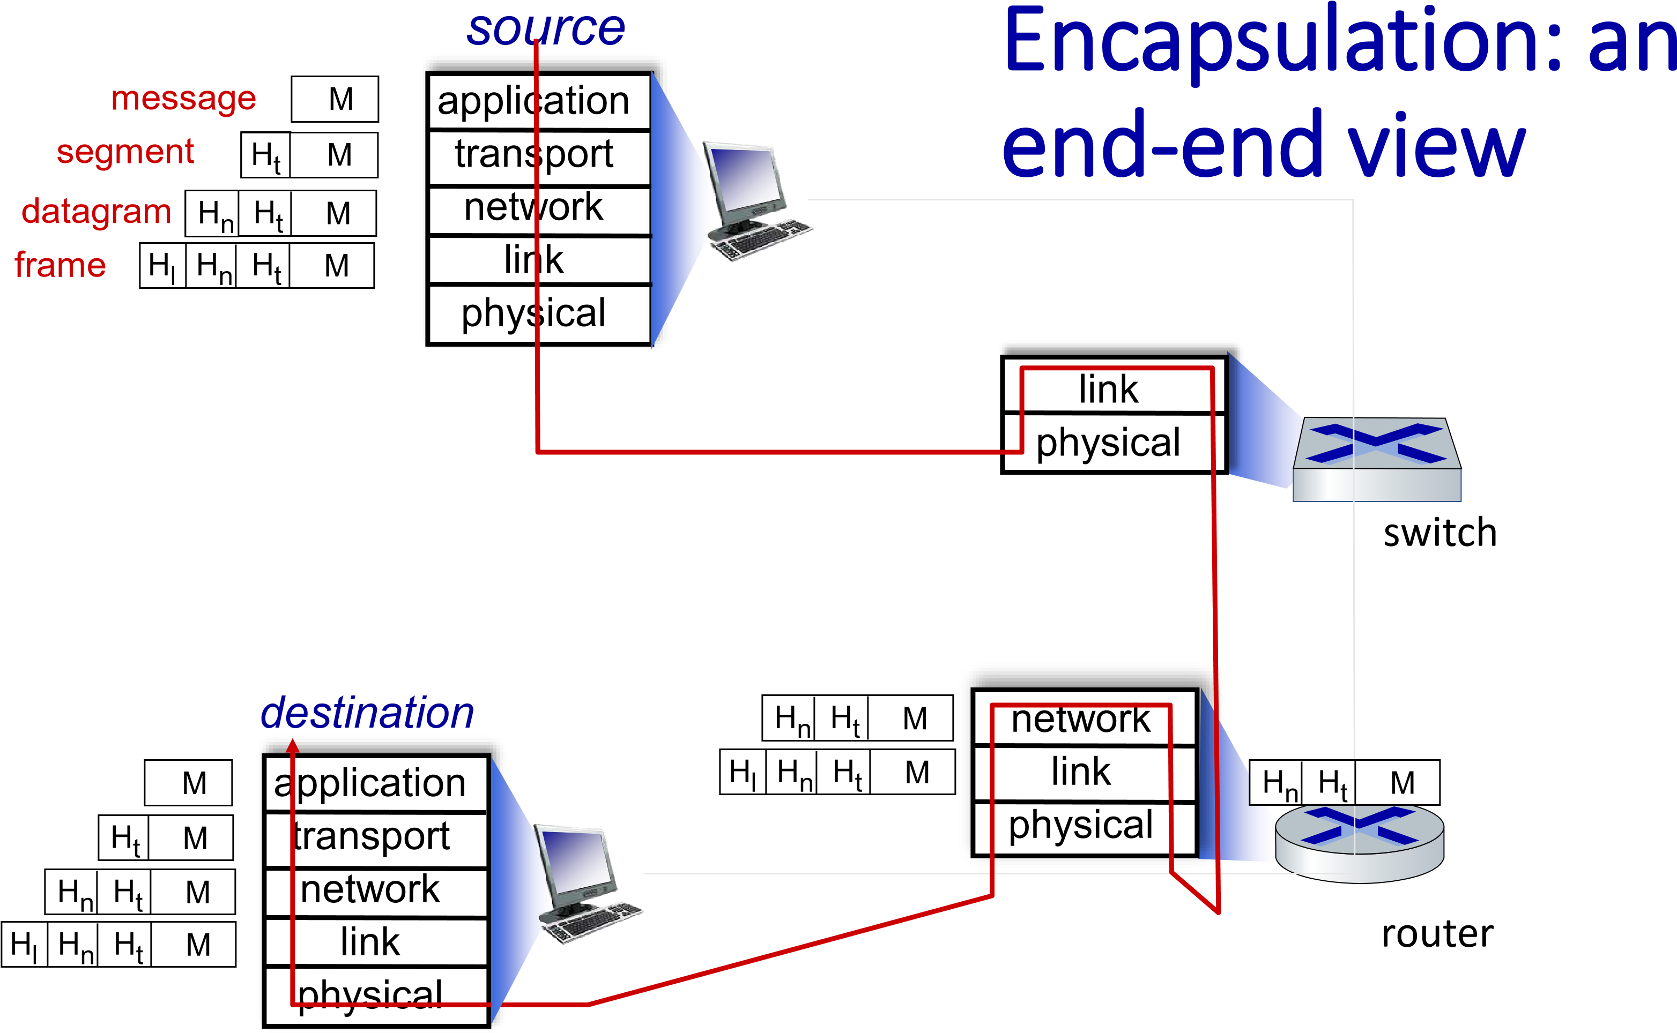
Introduction: 1-77

Chapter 1: roadmap
- What is the Internet?
- What is a protocol?
- Network edge: hosts, access network, physical media
- Network core: packet/circuit switching, internet structure
- Performance: loss, delay, throughput
- Security
- Protocol layers, service models
- History
Introduction: 1-78
1961-1972: Early packet-switching principles

- 1961: Kleinrock - queueing theory shows effectiveness of packet-switching
- 1964: Baran - packet-switching in military nets
- 1967: ARPAnet conceived by Advanced Research Projects
Agency
- 1969: first ARPAnet node operational
- 1972:
  - ARPAnet public demo
  - NCP (Network Control Protocol) first host-host protocol
  - first e-mail program
  - ARPAnet has 15 nodes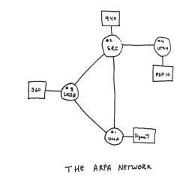

1972-1980: Internetworking, new and proprietary networks
- 1970: ALOHAnet satellite network in Hawaii
Cerf and Kahn’s internetworking principles:
- minimalism, autonomy - no internal changes required to interconnect networks
- best-effort service model
- stateless routing
- decentralized control define today’s Internet architecture
- 1974: Cerf and Kahn architecture for interconnecting networks
- 1976: Ethernet at Xerox PARC
- late70’s: proprietary architectures: DECnet, SNA, XNA
- 1979: ARPAnet has 200 nodes
1980-1990: new protocols, a proliferation of networks

- 1983: deployment of TCP/IP
- 1982: smtp e-mail protocol defined
- 1983: DNS defined for nameto-IP-address translation
- 1985: ftp protocol defined
- 1988: TCP congestion control ▪ new national networks: CSnet,
BITnet, NSFnet, Minitel
- 100,000 hosts connected to confederation of networks
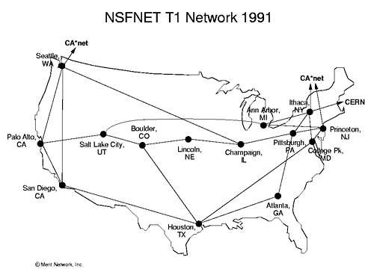 Introduction: 1-81
- early 1990s: ARPAnet decommissioned
1990, 2000s: commercialization, the Web, new applications
- 1991: NSF lifts restrictions on commercial use of NSFnet
(decommissioned, 1995)
- early 1990s: Web
  - hypertext [Bush 1945, Nelson 1960’s]
  - HTML, HTTP: Berners-Lee
  - 1994: Mosaic, later Netscape
  - late 1990s: commercialization of the
Web
late 1990s – 2000s:
- more killer apps: instant messaging, P2P file sharing
- network security to forefront
- est. 50 million host, 100 million+ users
- backbone links running at Gbps

2005-present: scale, SDN, mobility, cloud
- aggressive deployment of broadband home access (10-100’s Mbps)
- 2008: software-defined networking (SDN)
- increasing ubiquity of high-speed wireless access: 4G/5G, WiFi
- service providers (Google, FB, Microsoft) create their own networks
• bypass commercial Internet to connect “close” to end user, providing
“instantaneous” access to social media, search, video content, …
- enterprises run their services in “cloud” (e.g., Amazon Web Services, Microsoft Azure)
- rise of smartphones: more mobile than fixed devices on Internet (₂₀₁₇₎
- ~15B devices attached to Internet (2023, statista.com)
Introduction: 1-83

Chapter 1: summary
We’ve covered a “ton” of material!
- Internet overview ▪ what’s a protocol?
- network edge, access network, core
  - packet-switching versus circuitswitching
  - Internet structure
- performance: loss, delay, throughput
- layering, service models
- security
- history
You now have:
- context, overview, vocabulary, “feel” of networking
- more depth,
detail, and fun to follow!

Additional Chapter 1 slides
Introduction: 1-85

ISO/OSI reference model
Two layers not found in Internet protocol stack!
- presentation: allow applications to interpret meaning of data, e.g., encryption, compression, machine-specific conventions
- session: synchronization, checkpointing, recovery of data exchange
- Internet stack “missing” these layers!
  - these services, if needed, must be implemented in application
  - needed?
application
presentation session
transport network link
physical
The seven layer OSI/ISO reference model
Introduction: 1-86

Services, Layering and Encapsulation
application
transport
network
link
physical
application
transport
network
link
physical
H
t
M
M
M
H
t
H
n
M
H
t
H
n
H
l
M
H
t
H
n
H
t
M
M
message
segment
datagram
frame
M
H
t
H
n
H
l
source destination
Introduction: 1-87

Wireshark
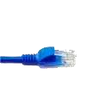
Transport
)
TCP/UDP
(
Network
(
)
IP
Link
)
Ethernet
(
Physical
application
(
www browser,
email client
)
application
OS
packet
capture
(
pcap
)
packet
analyzer
copy of all
Ethernet frames
sent/received
Introduction: 1-88

